Here Its an Instruction About How to Installation and Run Source Code of Node J

Step 1: check the System Architecture (32 bit or 64 bit) and download Accordingly

- FYI(For Your Info ) 32 bit is an x86 Architecture

And 64 bit is an x64 Architecture

Let Get Back to Steps

To see that go to MyPC -> right click -> properties

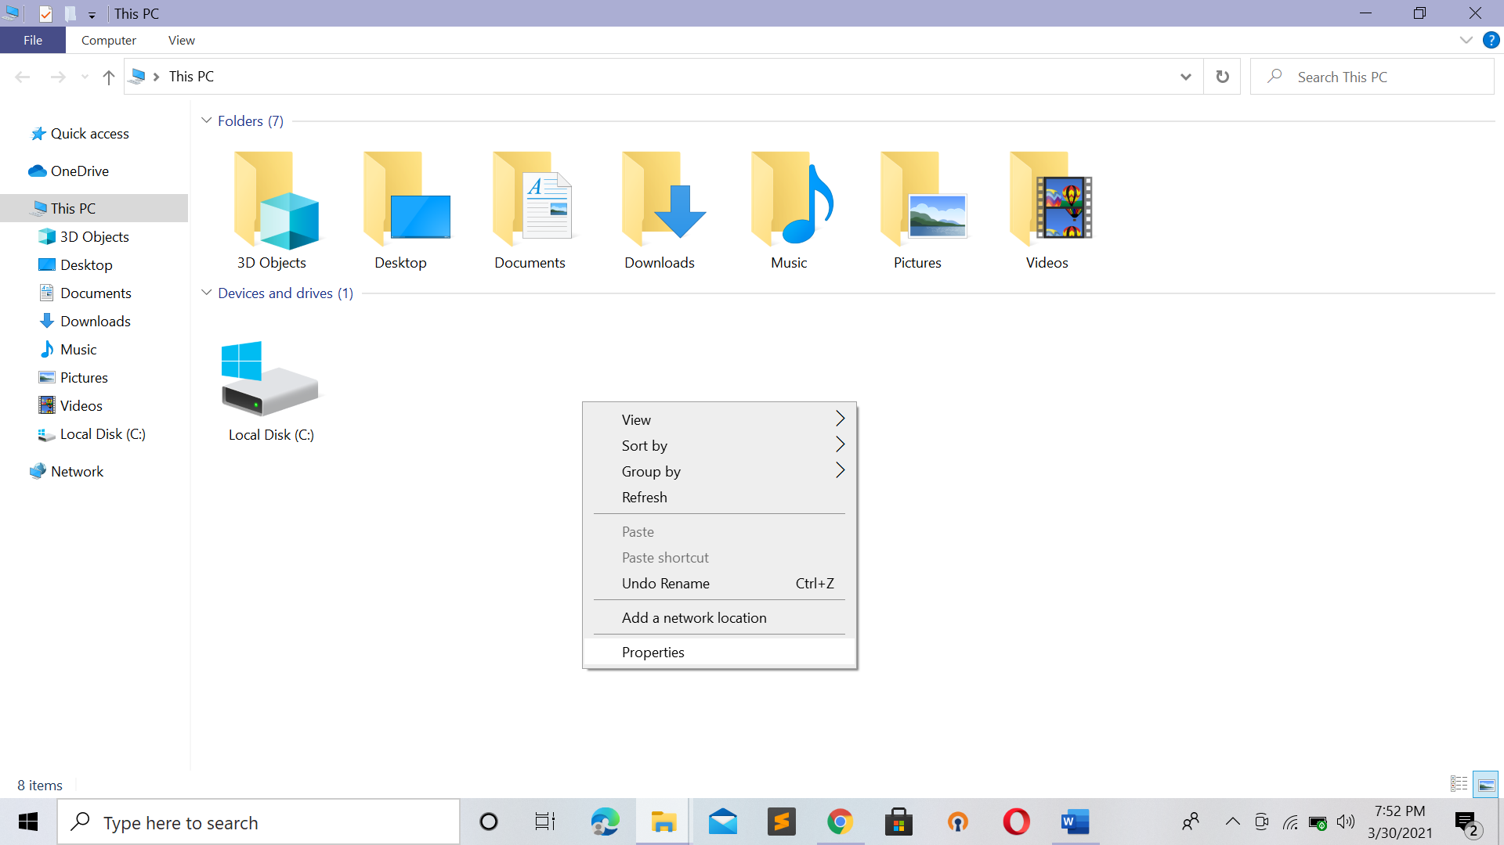

Once U click on properties this dialog will popup

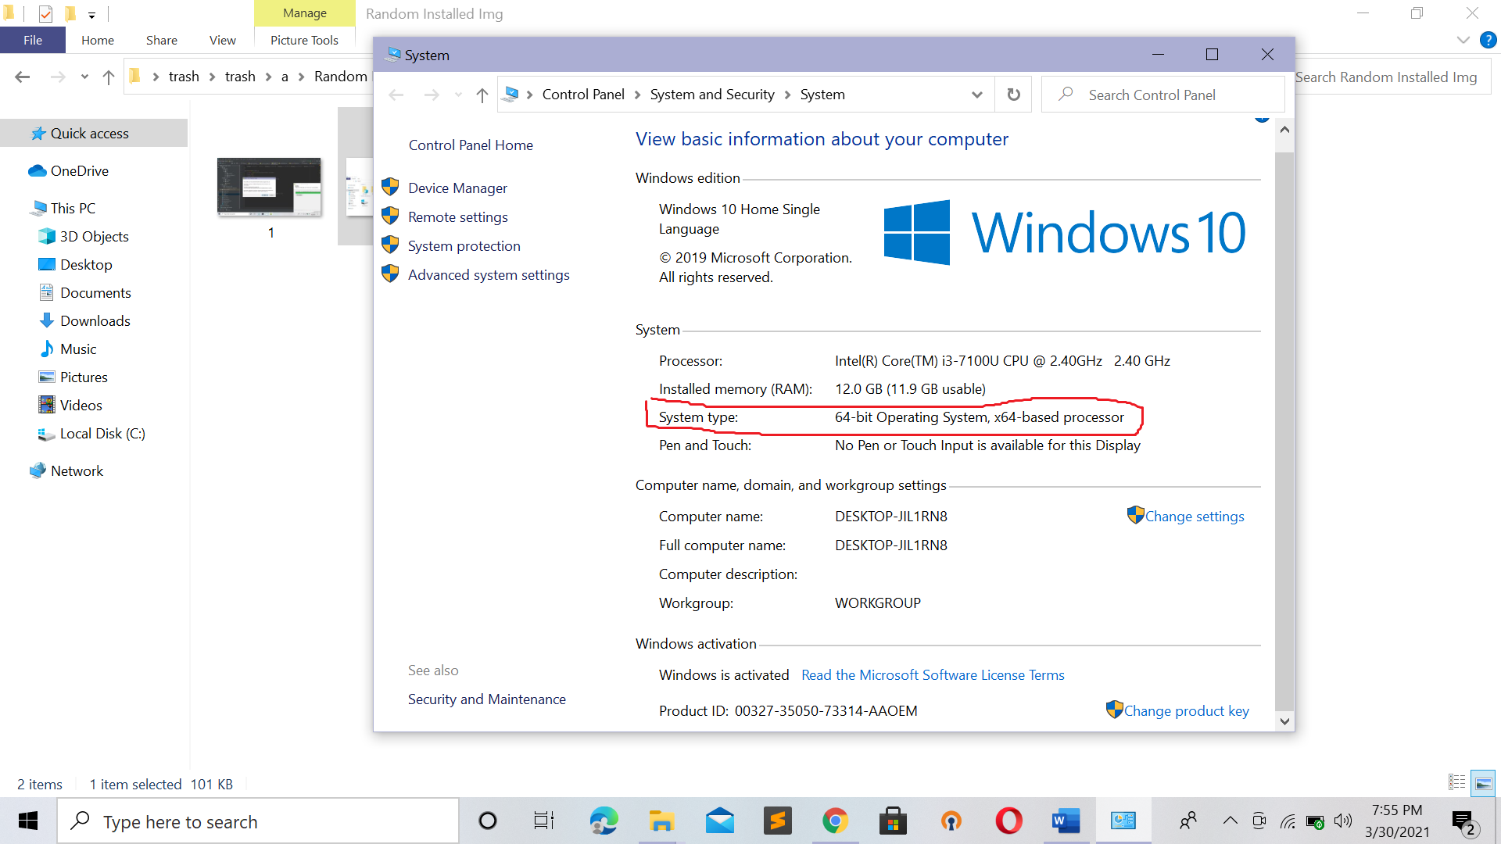

In My case It has 64 Bit . Now If Processor is Older It can Have 32 Bit .

So According to this download Node JS

Link for 32 Bit OS : <https://nodejs.org/download/release/v10.19.0/node-v10.19.0-win-x86.zip>

Link for 64 Bit OS : <https://nodejs.org/download/release/v10.19.0/node-v10.19.0-win-x64.zip>

Its like 17.7 MB

Basically Its in Zip file so extract I GO inside That File

Path : node-v10.19.0-win-x64\node-v10.19.0-win-x64

U Will See Like This :

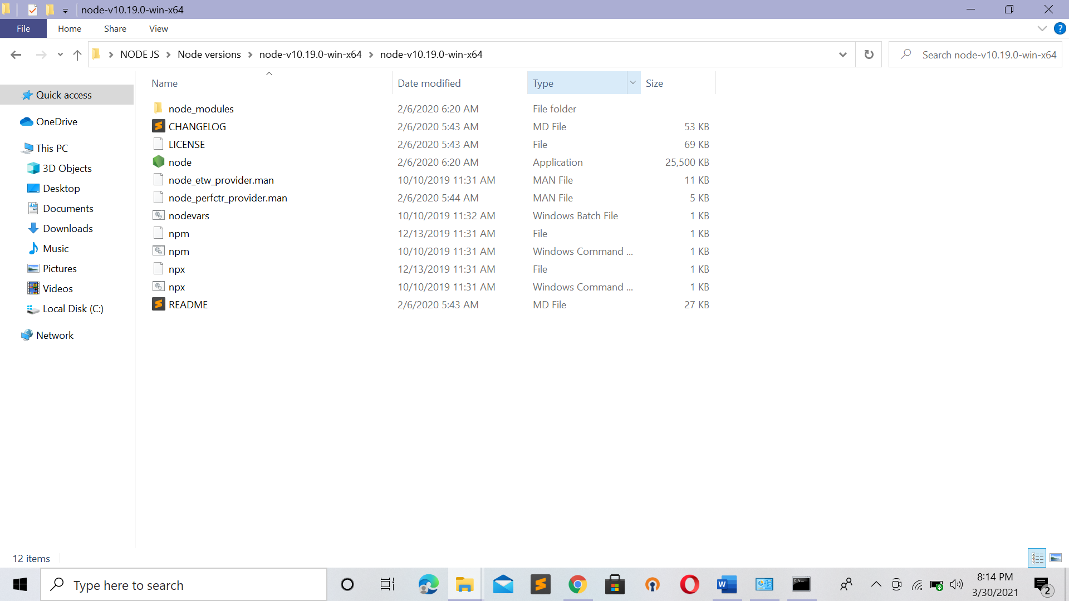

Copy Current Path of Node JS and save to environment variable

Steps : 1) Copy the Path of Node JS

Go to MyPc and right click and select properties

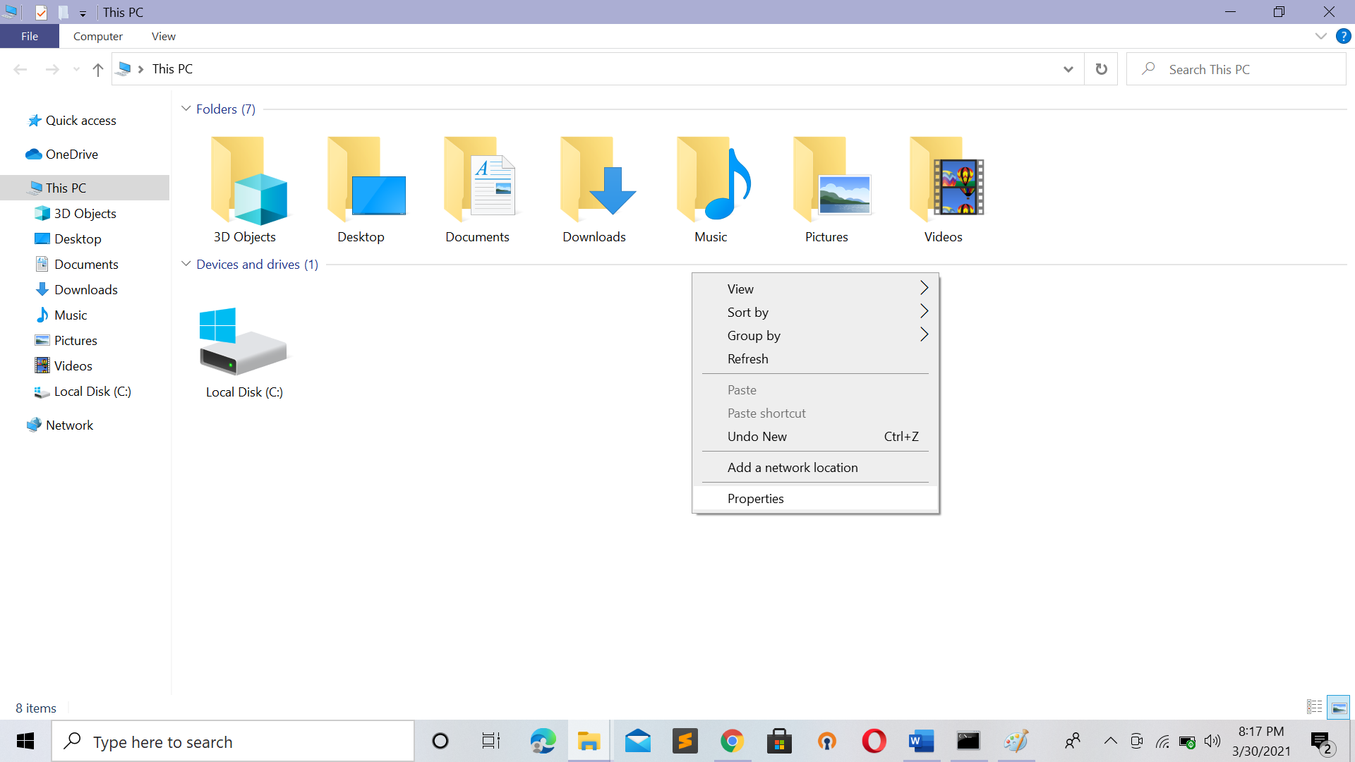

U Will see same dialog we has seen in 32 bit or 64 bit

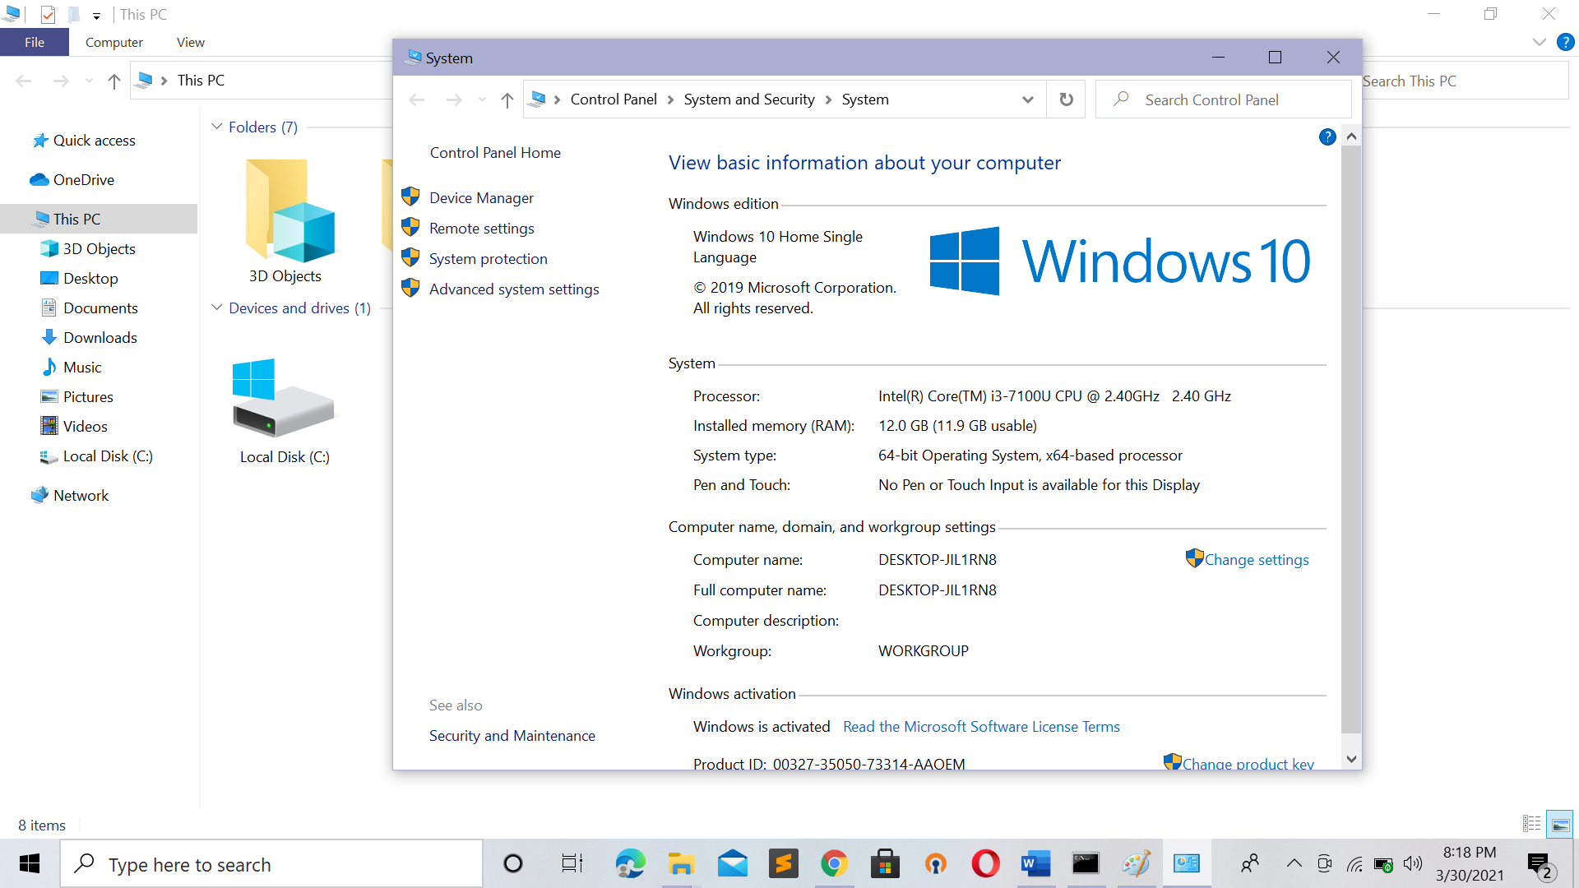

Select Advance System Setting

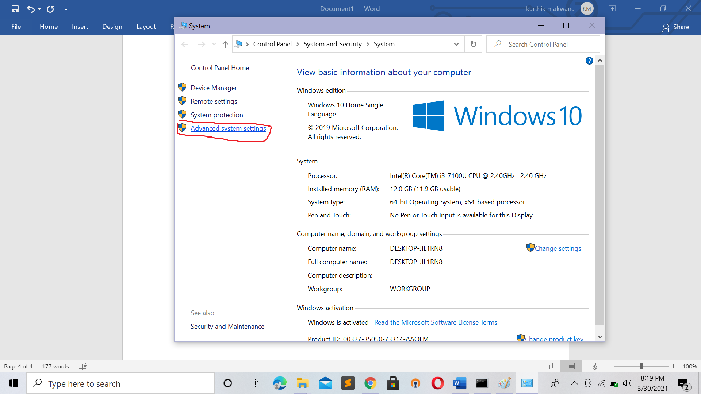

This one popped Out

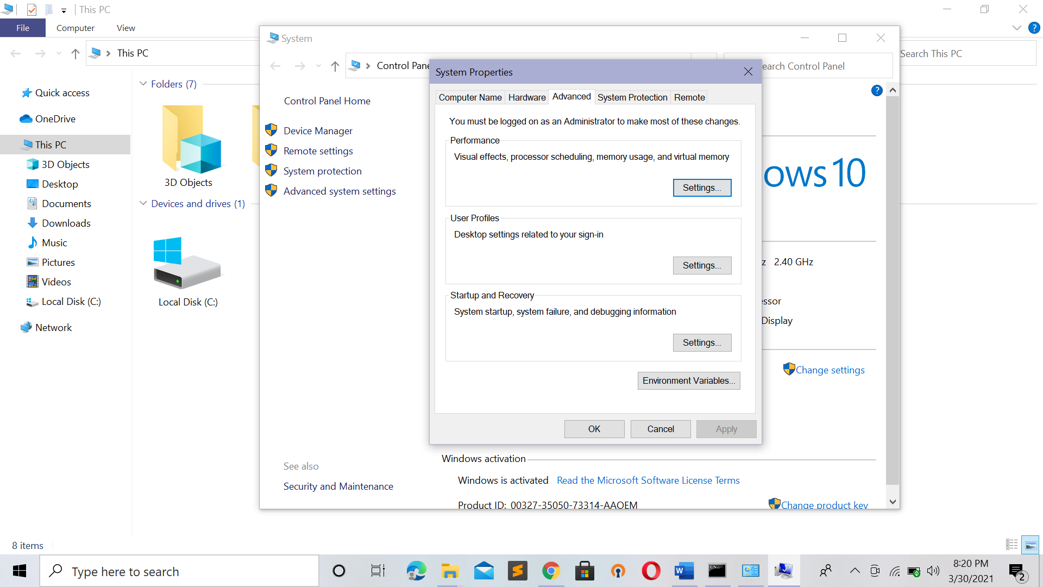

Select environment variable

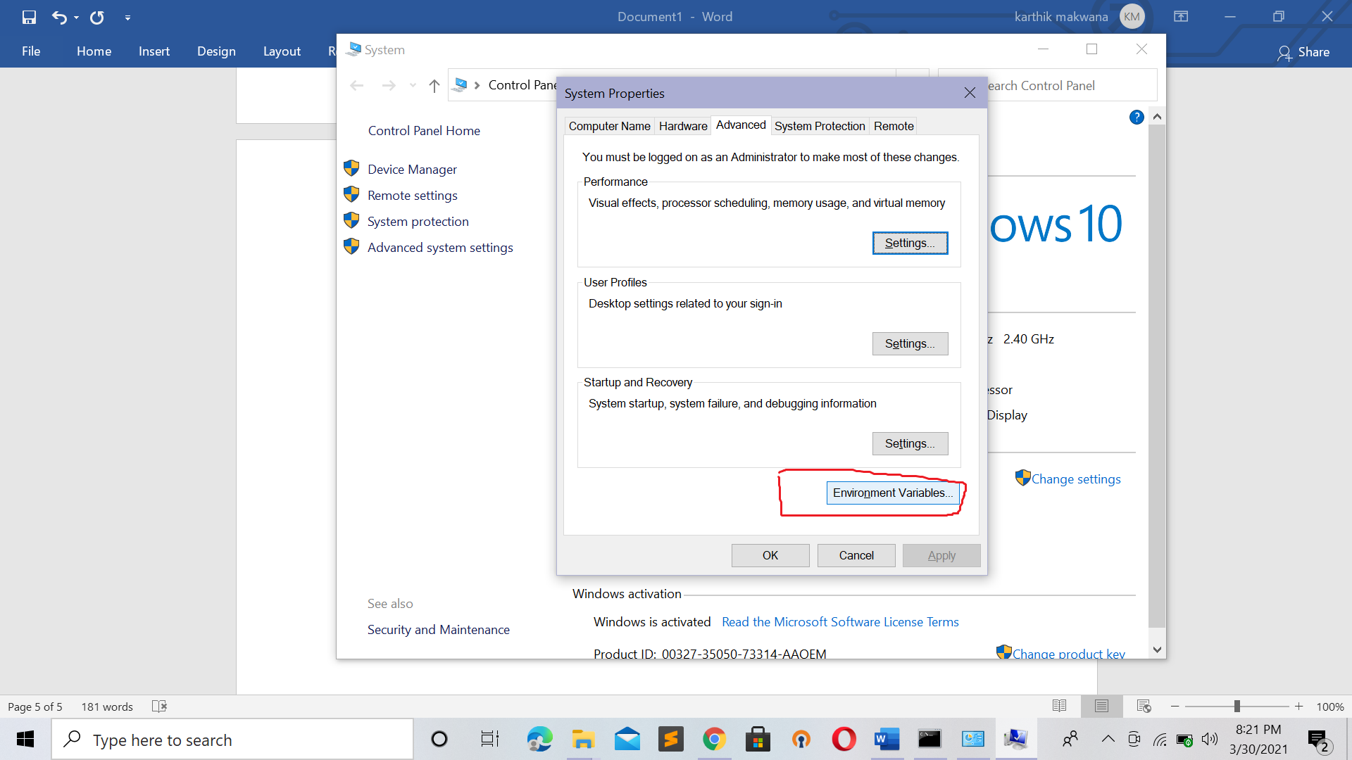

U gonna See This Dialog

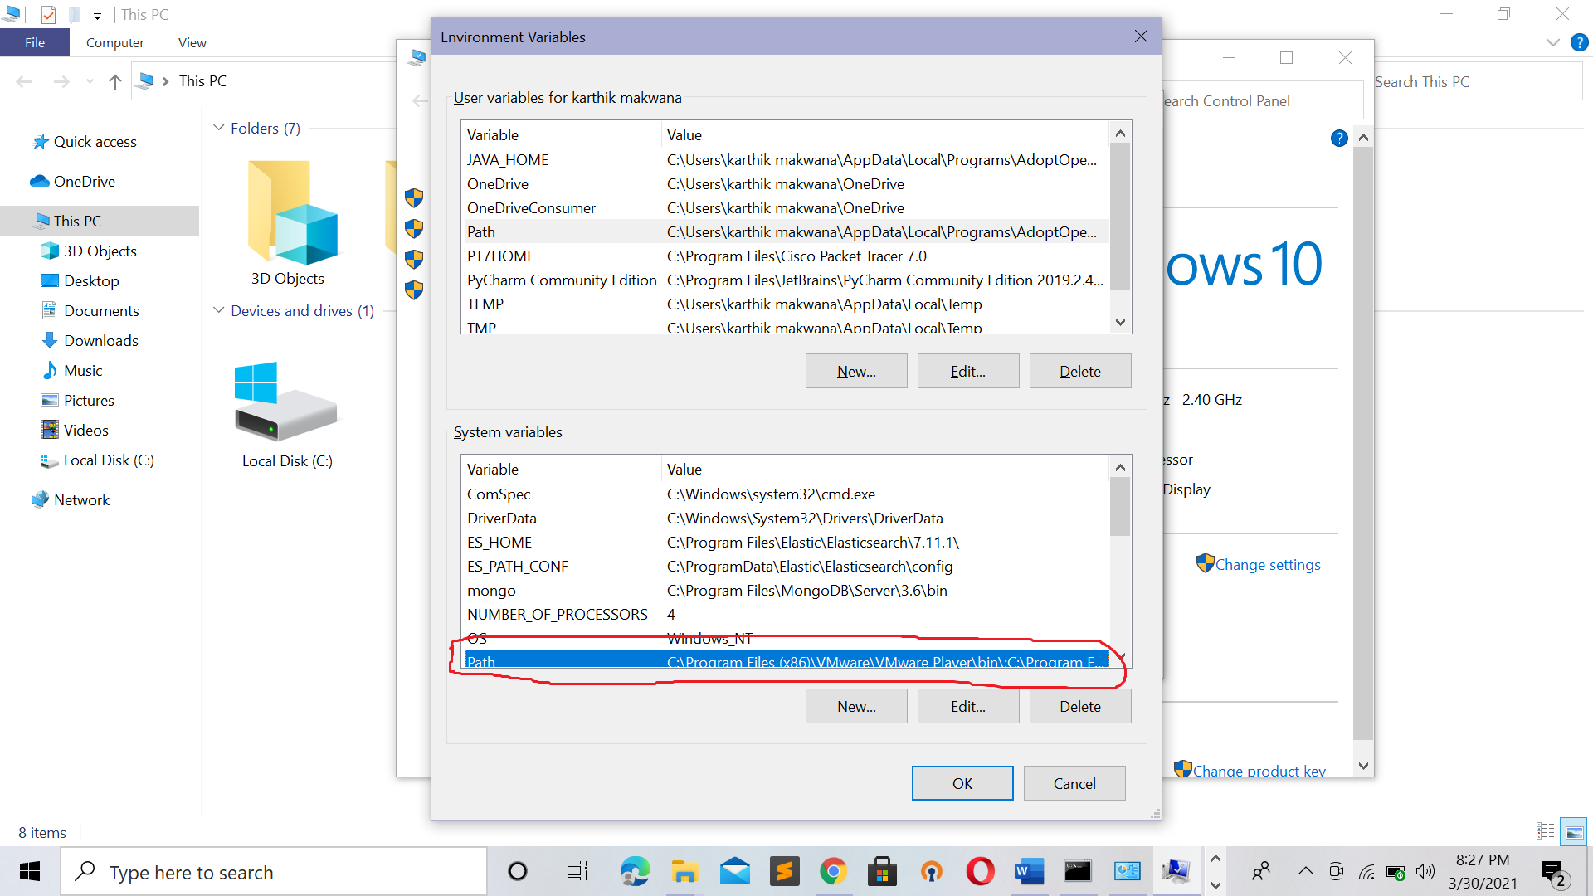

In System variable U gonna see path Even If It wont appear so scroll down Untill U get It

Click on that path U will See

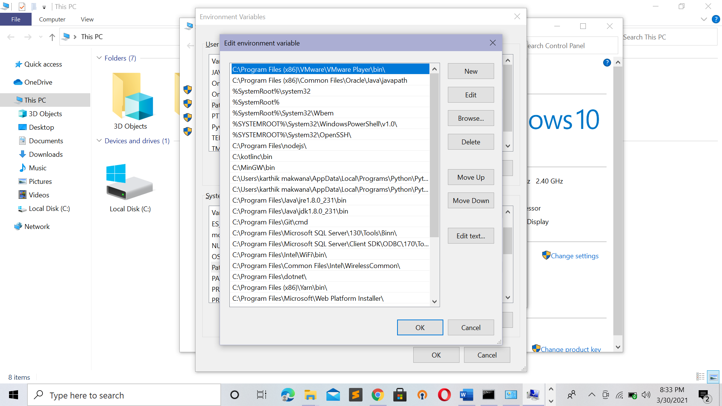

Under that Press New Button

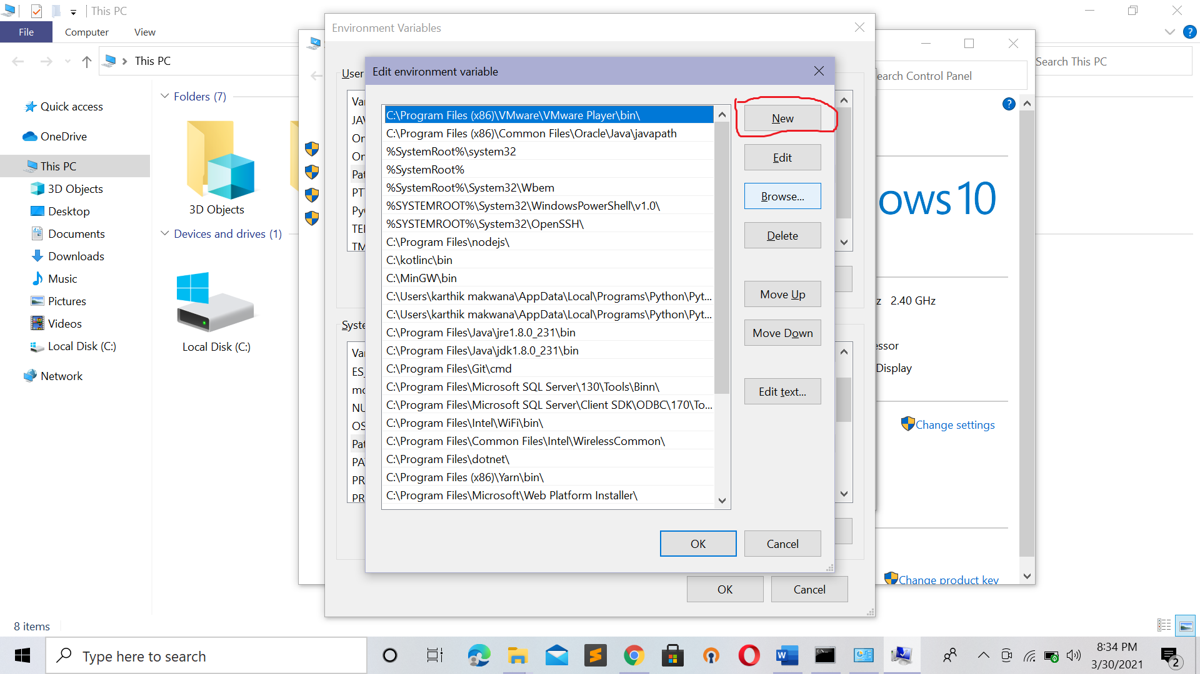

After clicking new Button U will see text Box so paste that dir of Node JS Over Here

And after click to OK Ok Ok to respective Dialog(window) .

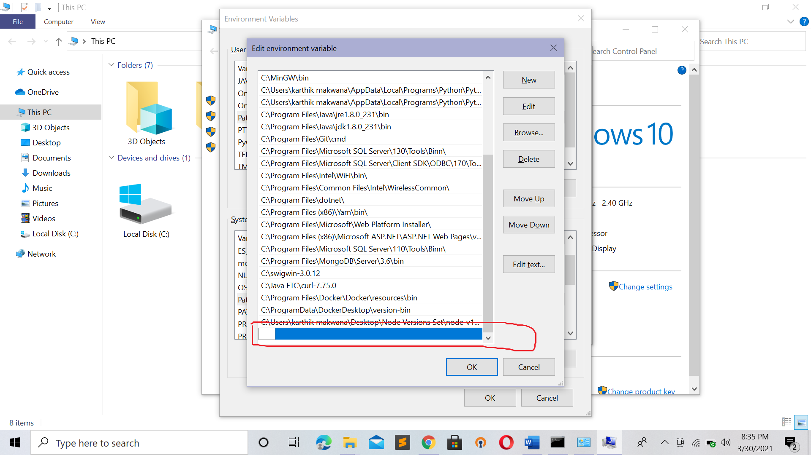

Step 2 : Downloading Database(MongoDB) :

Go To URL or Link : <https://www.mongodb.com/try/download/community>

Select verson 3.6.23 and download and Its Open It and click on next and install that software

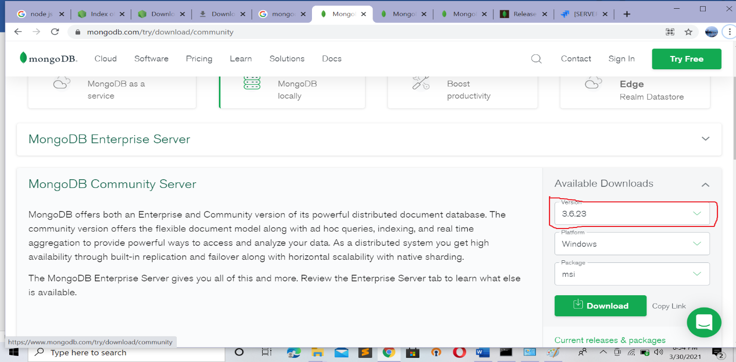

After all installation done U will see MongoDB Dir inside /Program Files

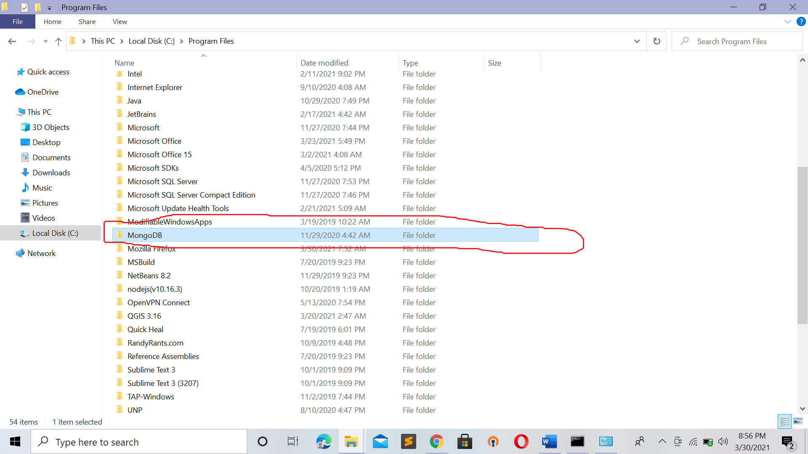

Go to this Path

MongoDB\Server\3.6\bin

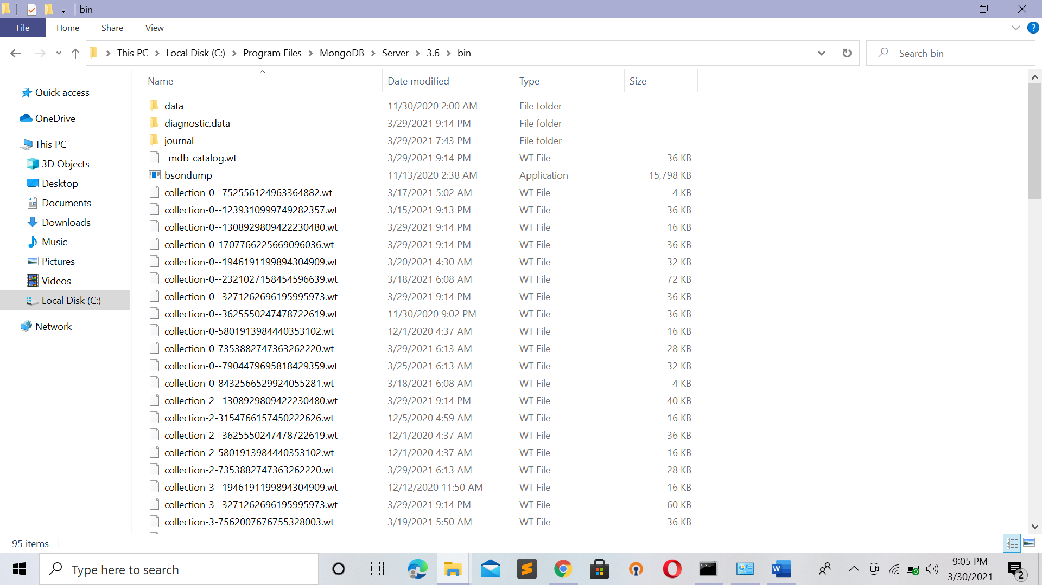

Copy that Bin Path In My case Full Dir is : C:\Program Files\MongoDB\Server\3.6\bin

It may vary according to Ur Dir

And Save that path to Environment Variable from Step 1 (Refer Step 1)

***Step 3:*** Repositor Download(Project Relinquish)

Go to the dir of project (An Project I Had Developed )

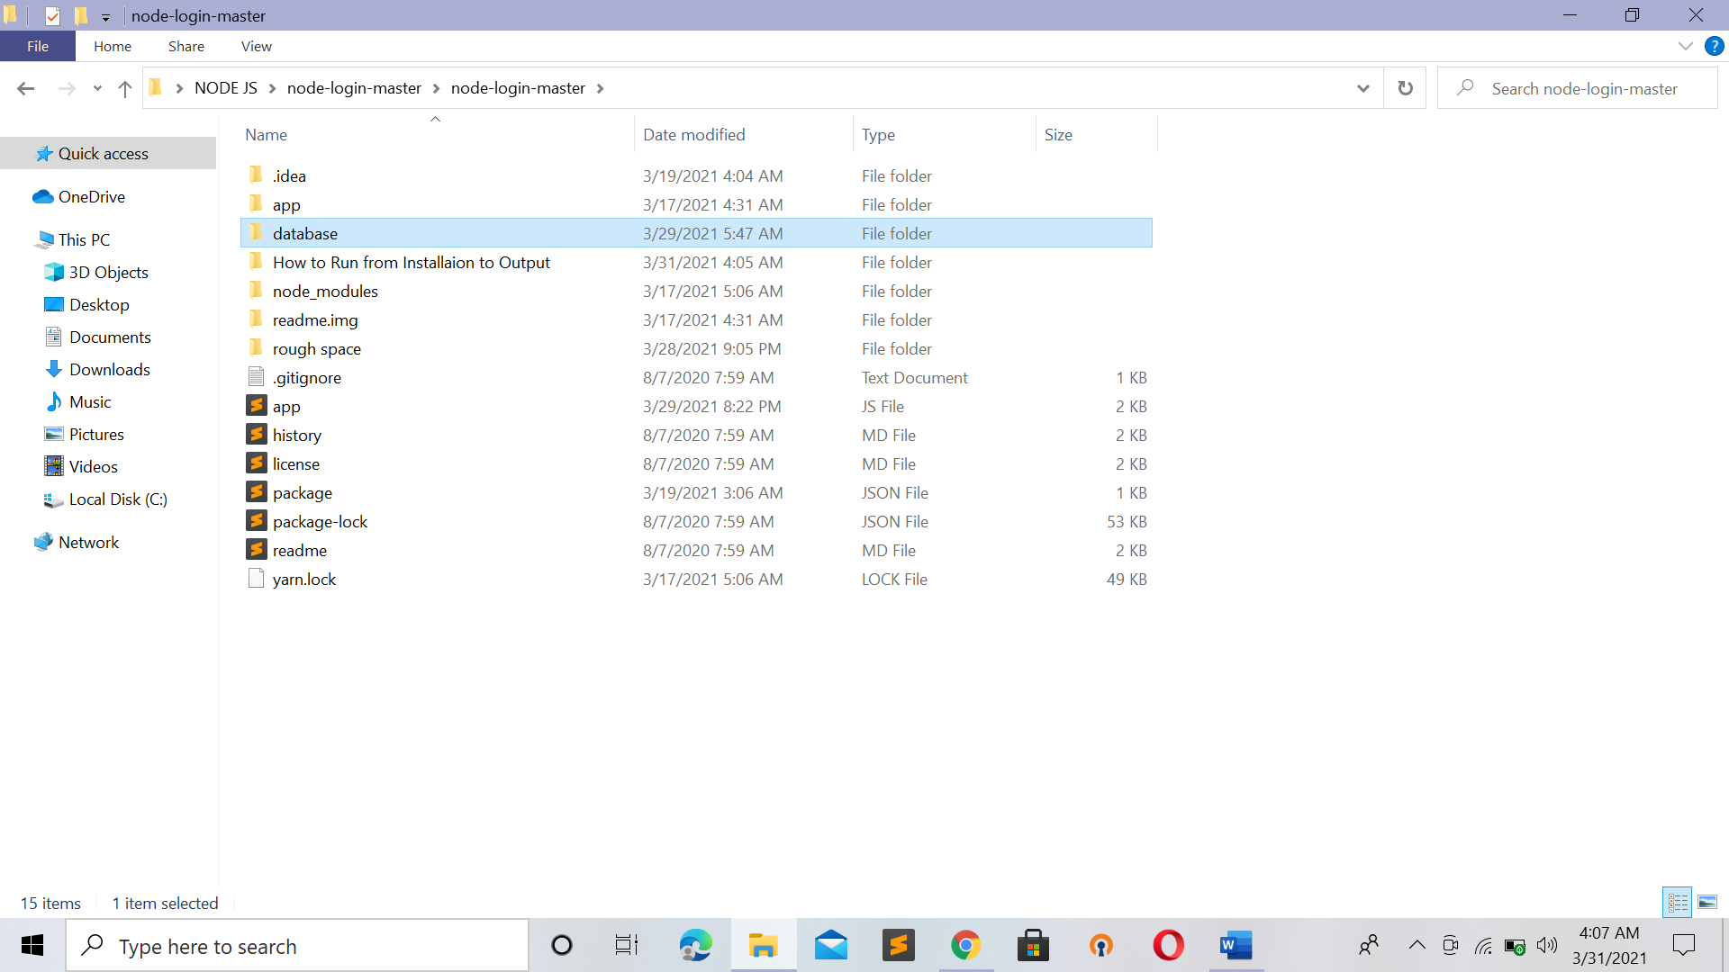

Copy the current Path and open cmd and change to current dir

Command : yarn

Press enter after that It will download the repository which is mention in

package.json

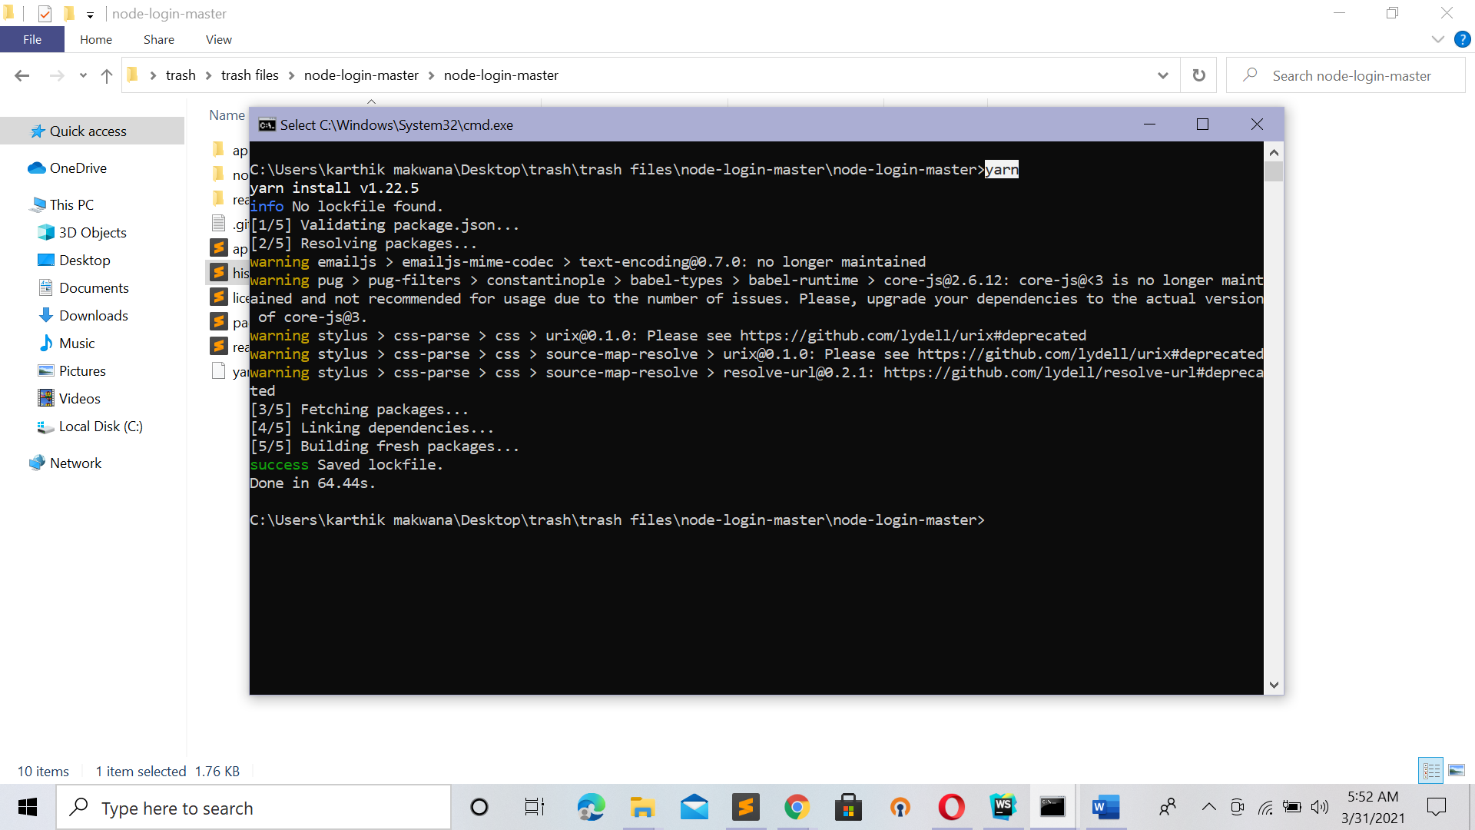

Exit command prompt after Downloaded all repository It will print the message

Success

**Step 4**: database Importing (.csv file )

Need to be precise over here . need to write exact database name and collection name

That we are using for Our website .

1. Start database(Turn ON)

Open Cmd With ADMINISTRATOR LEVEL Permission

By search cmd -> right click on It -> select Run as Administrator

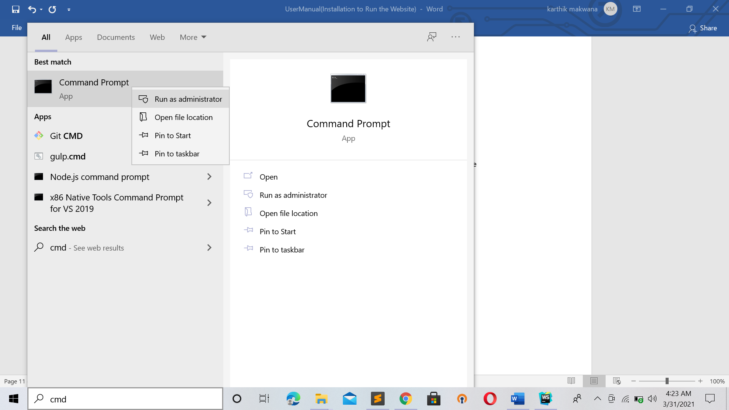

And then It will popup Message “DO U really Want this app to make change on Ur device”

With “yes” or “no” select “Yes”

After Entering CMD with Administrator Level

Command : mongod --dbpath "MongoDBPath Bin Path"

In My Case : mongod --dbpath "C:\Program Files\MongoDB\Server\3.6\bin"

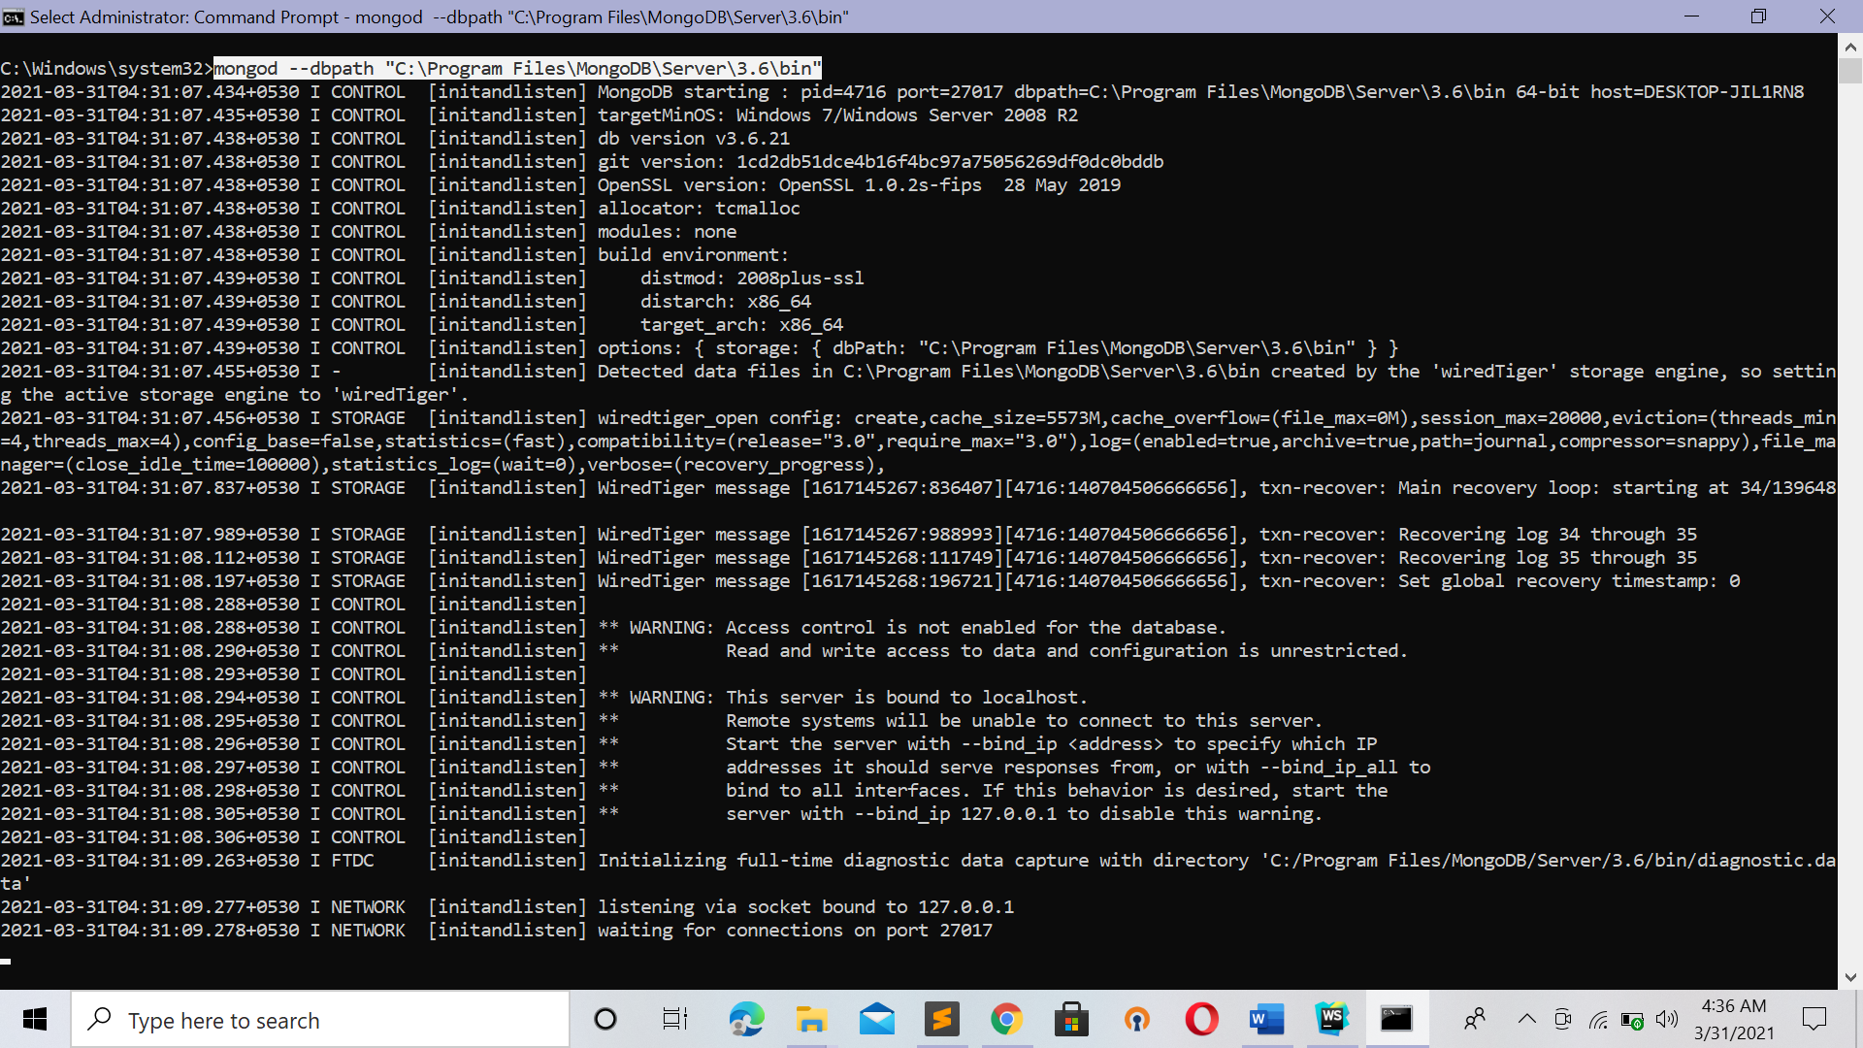

Now DB is waiting for Connectons

So Open New cmd

Command : mongo

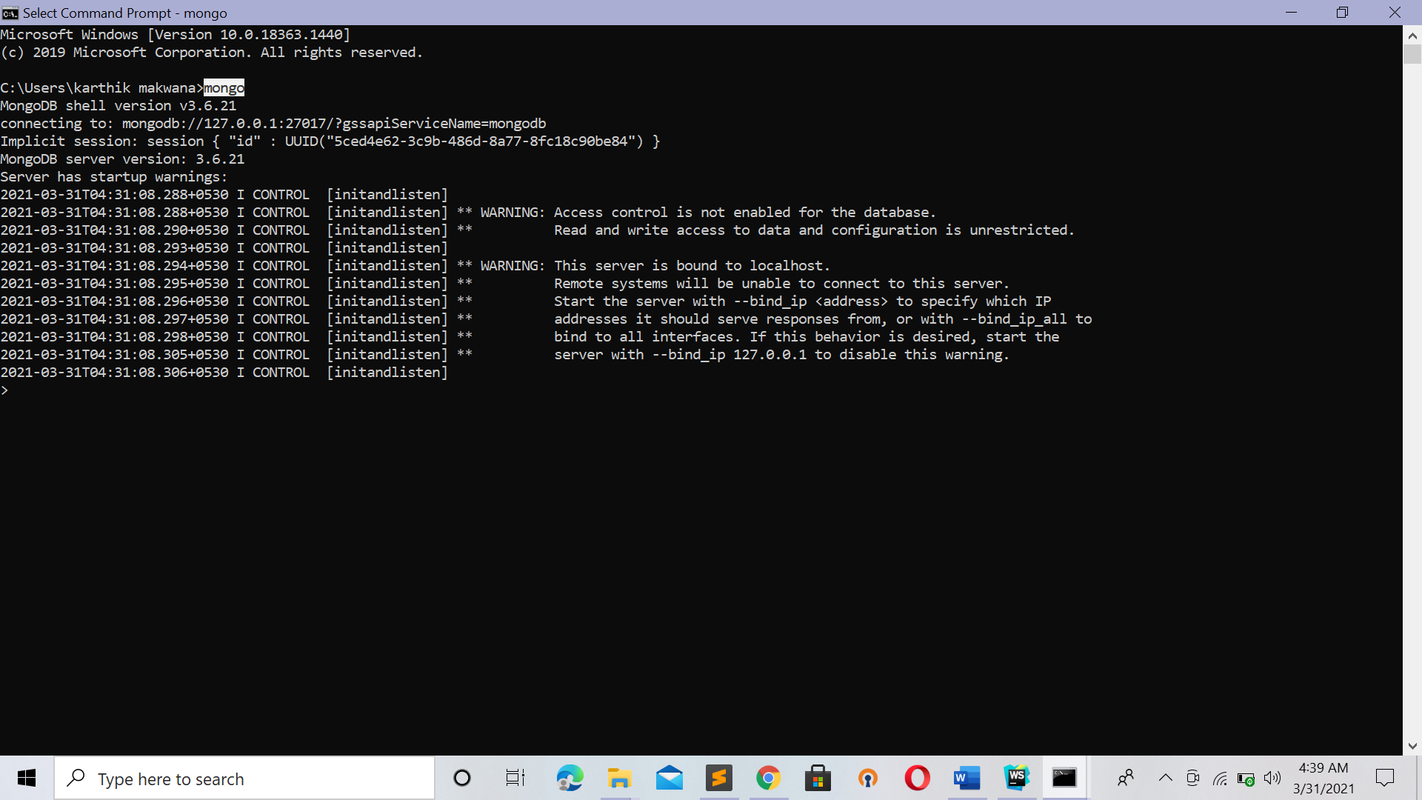

So This Indicate that U are connected to DB .

In Project U will see folder : database

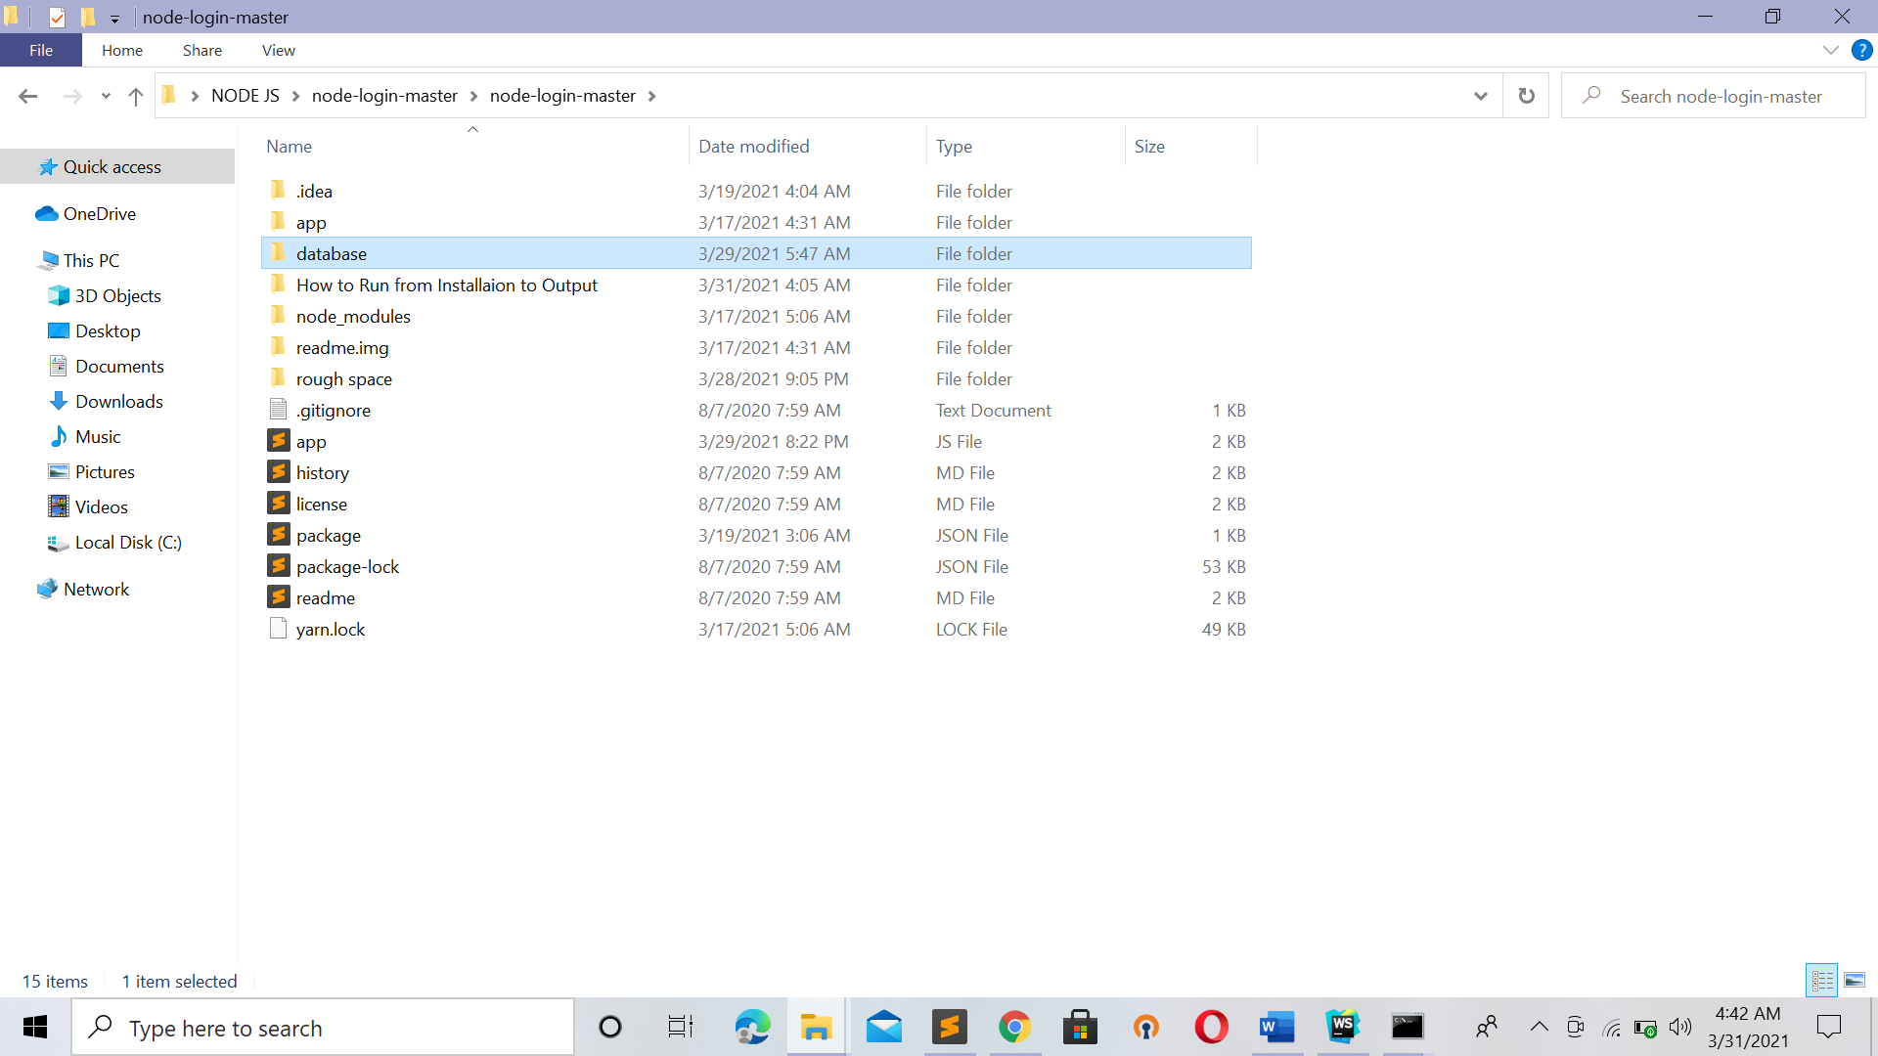

Go : database\updated Row Db

U will see random.csv file

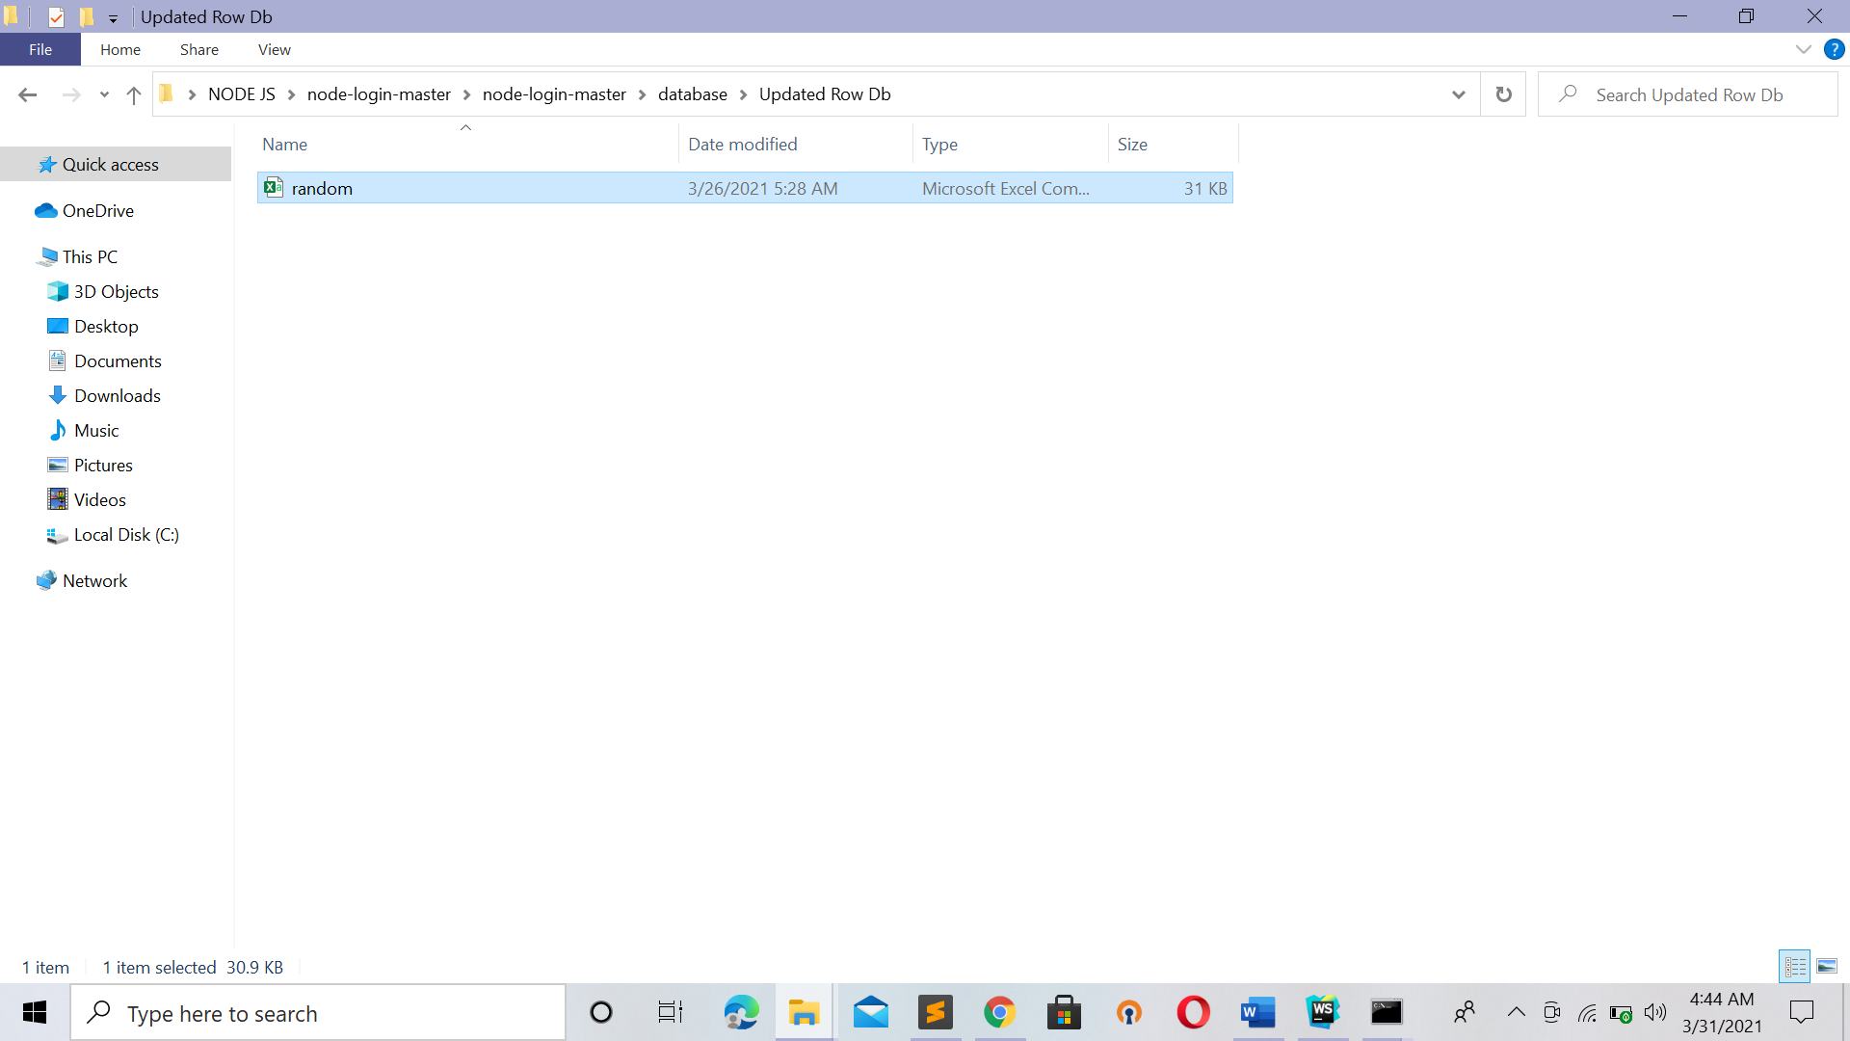

Open new CMD :

Change to current work dir

**Command** : mongoimport -d Prostate -c cancer_data --type csv --file "random.csv" –headerline

**U can gave Full Path of file also** :

mongoimport -d Prostate -c cancer_data --type csv --file "C:\Users\karthik makwana\Desktop\NODE JS\node-login-master\node-login-master\database\Updated Row Db\random.csv" –headerline

***Don’t change database name and collection name otherwise Website won’t work***

***Step 5 : Go back to Project Dir***

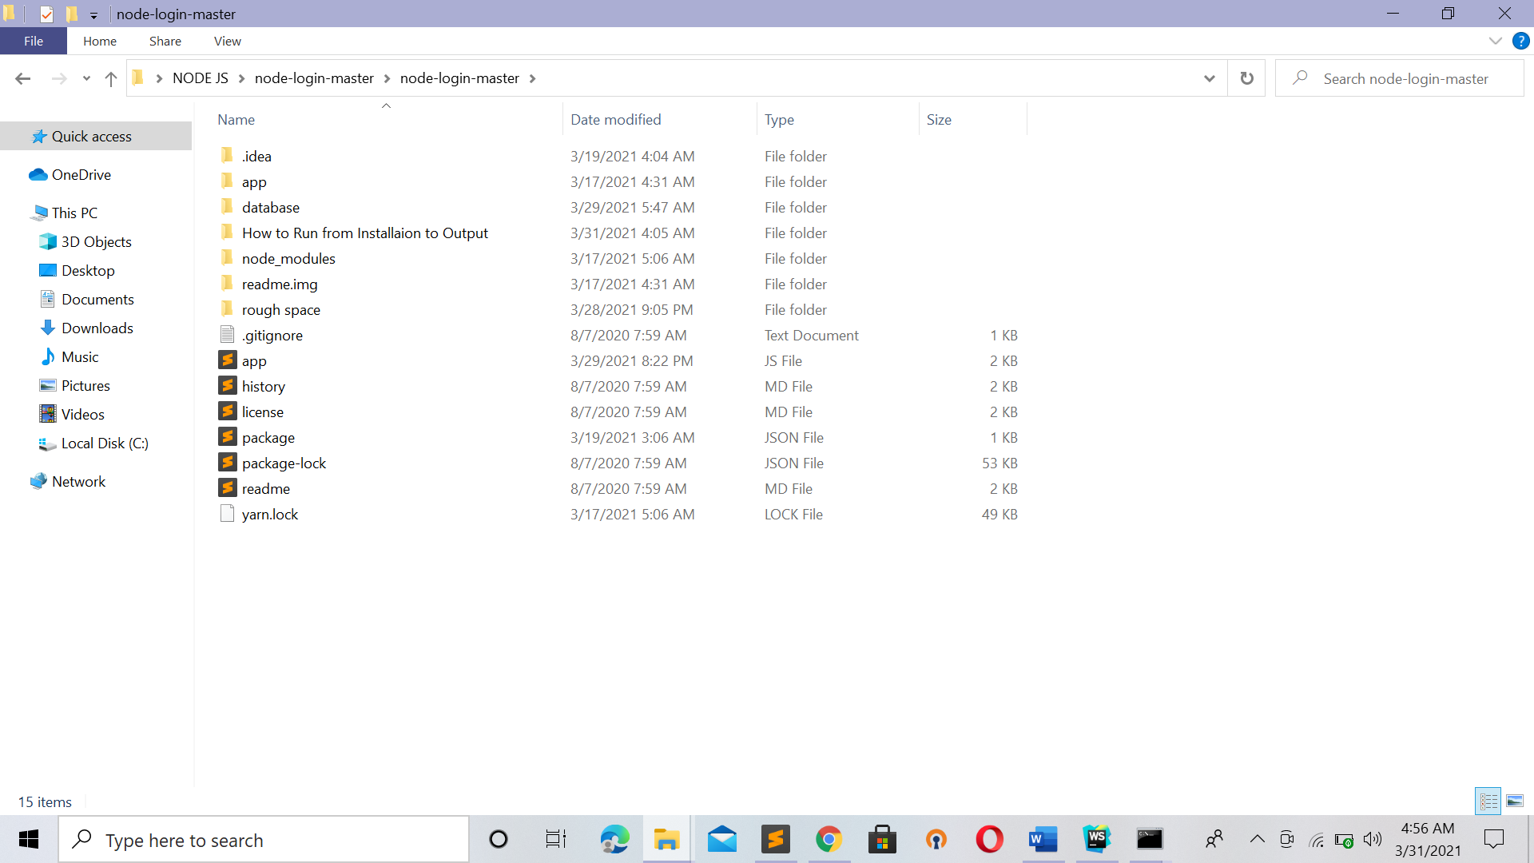

Open new cmd with this dir current dir

**Command:** node app.js

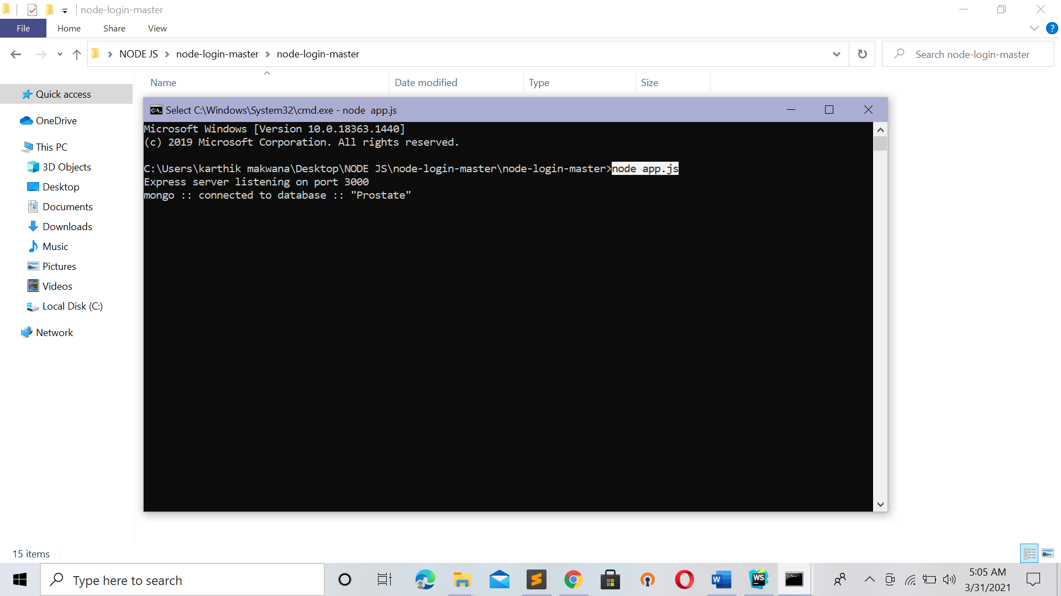

How go to Url : <http://localhost:3000/>

U will See This Page

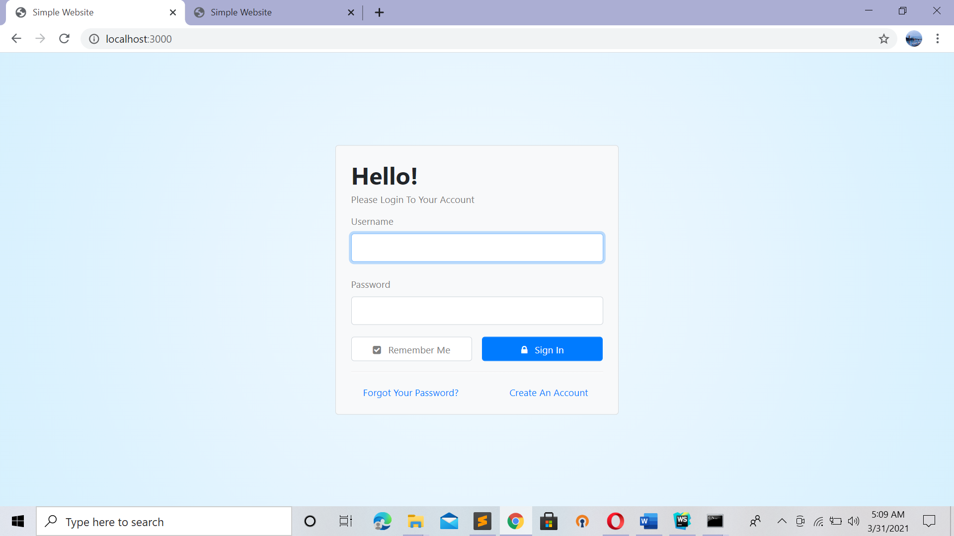

Login Directly If U had already Signup If Not then

Url : <http://localhost:3000/signup>

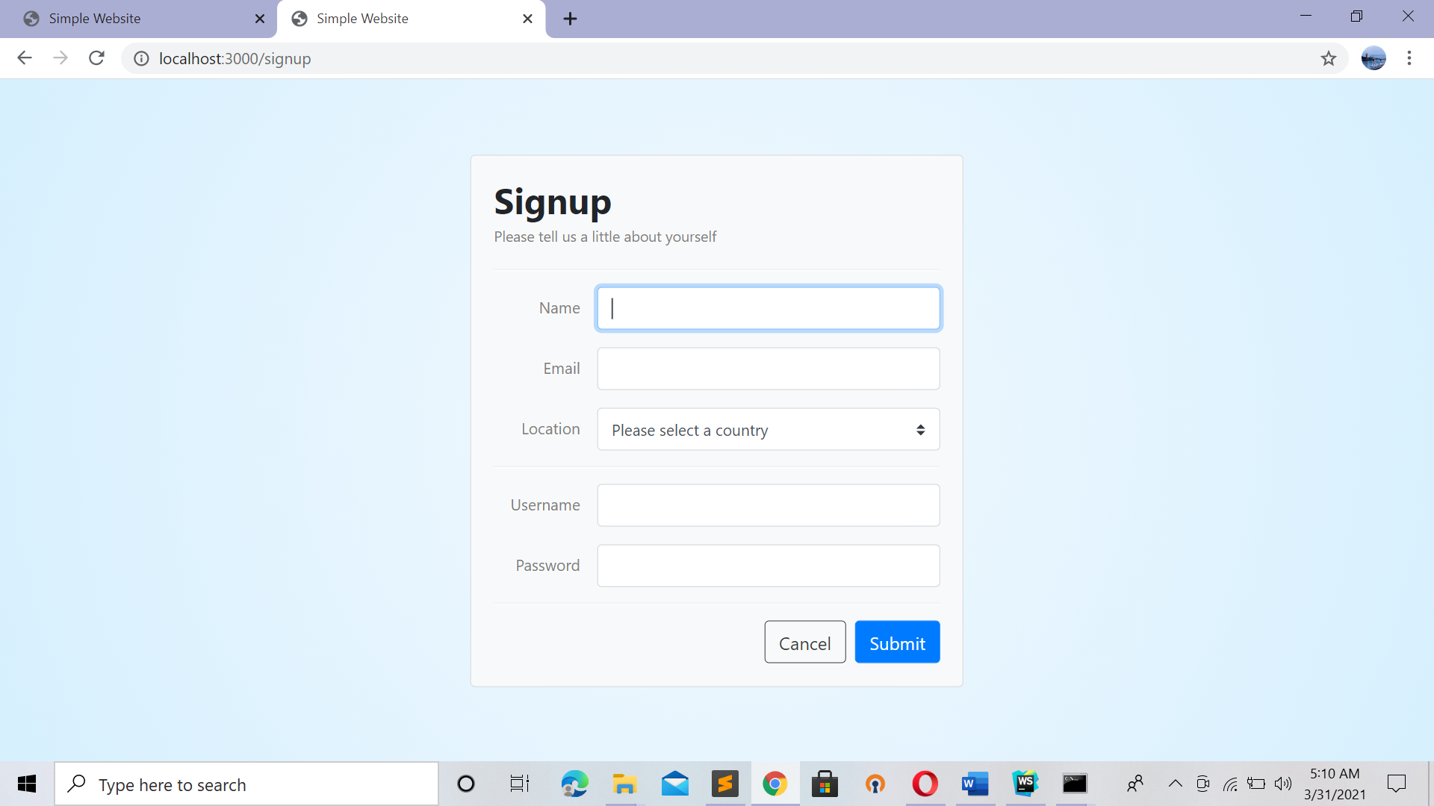

After Login U will See

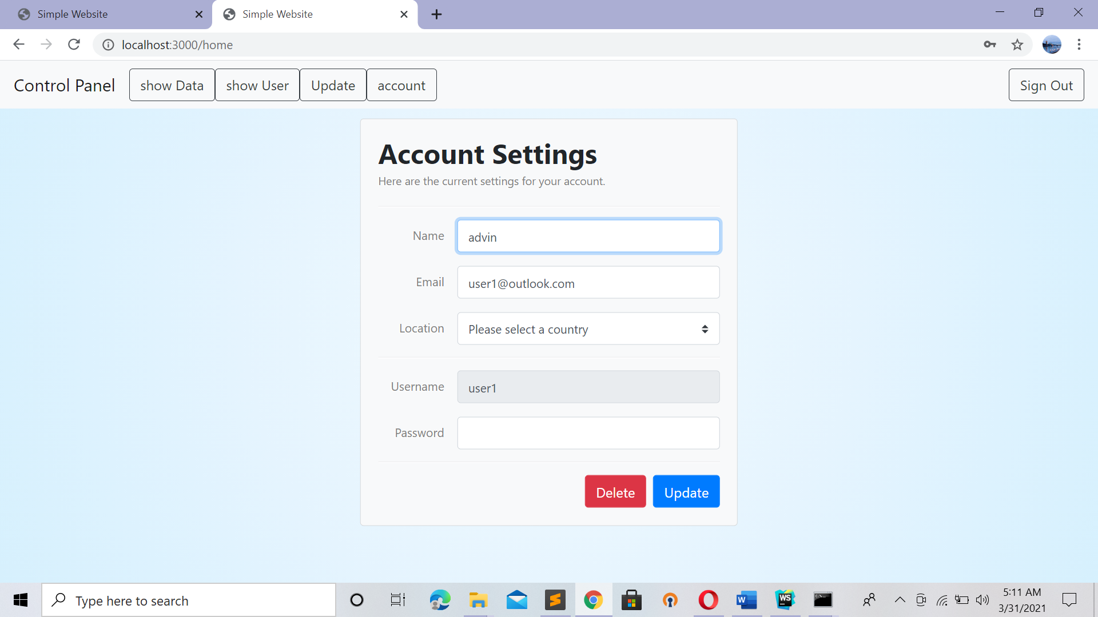

Show data -> click will gave all data which we had imported from random.csv file and Updated also

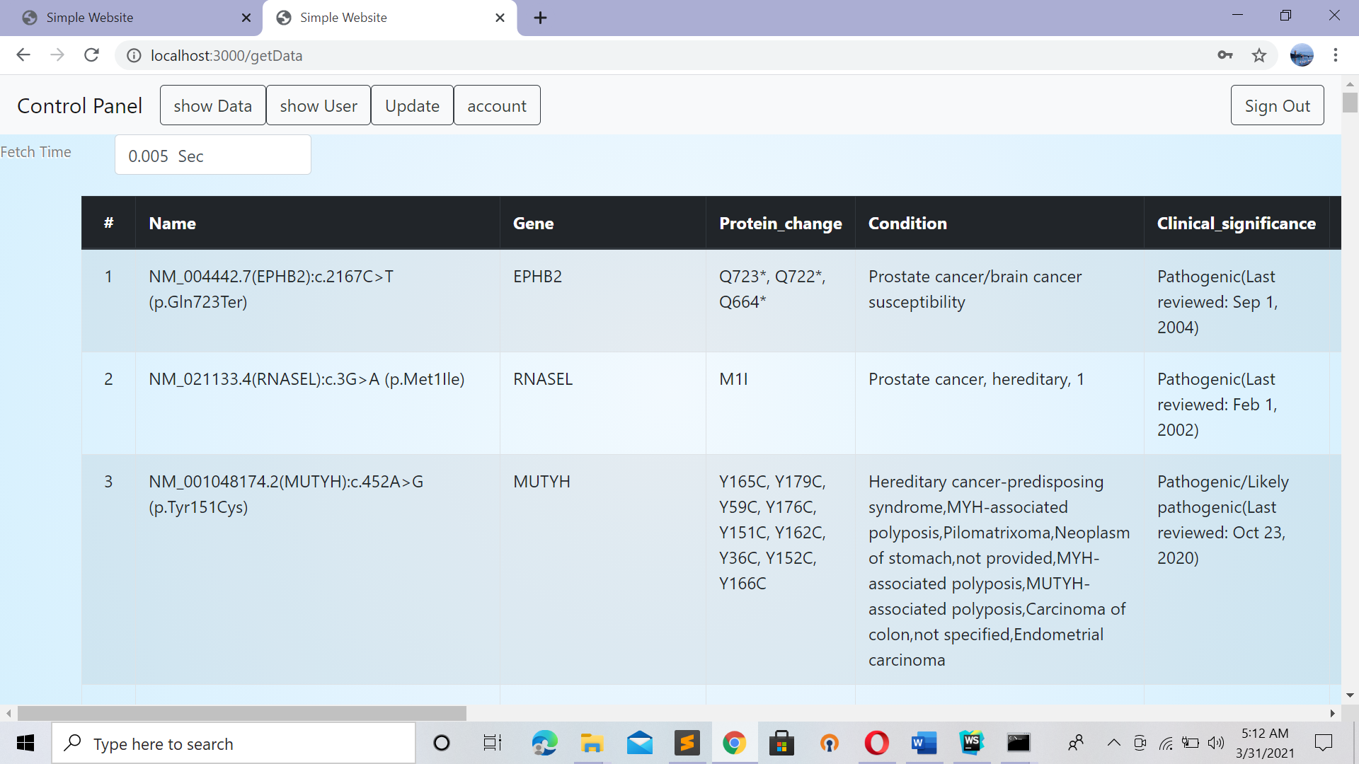

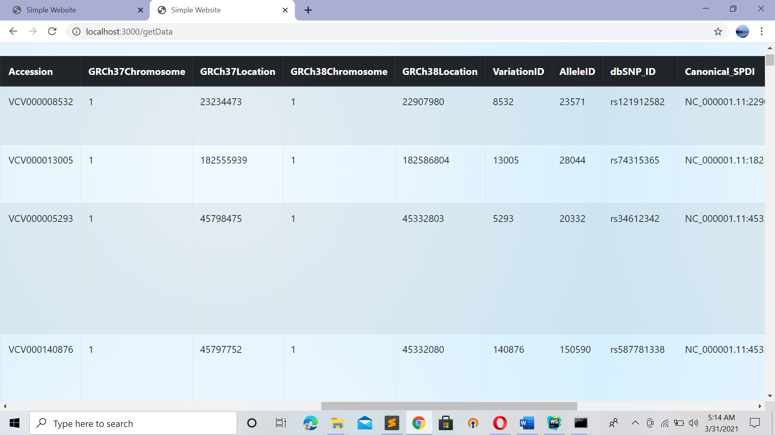

Show user -> click will give all all user Info

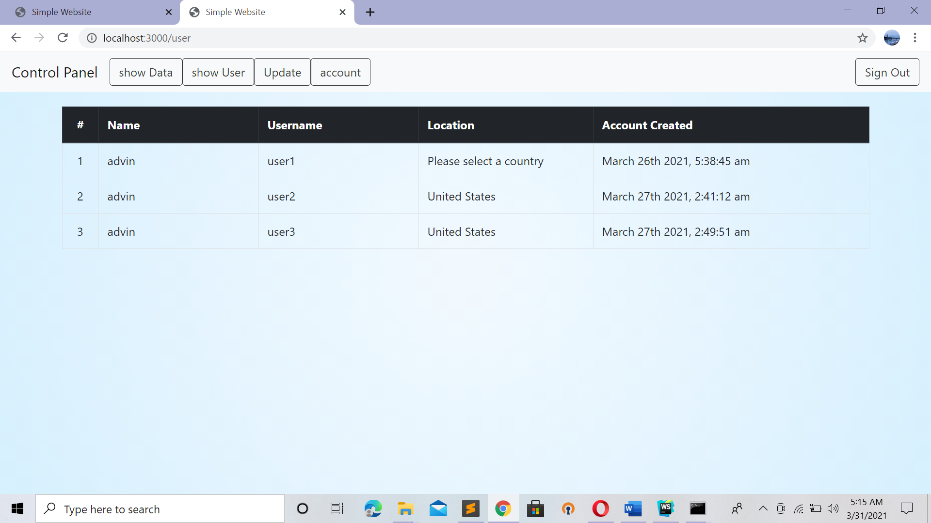

Update -> click

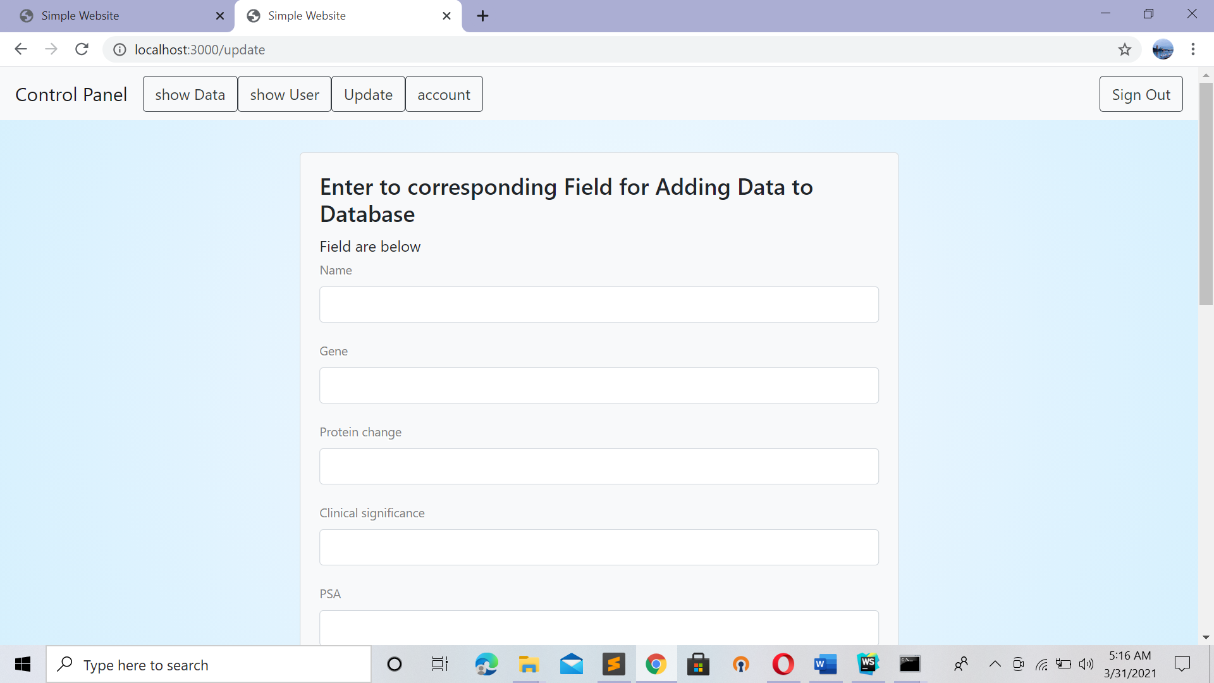

Fill the correspondence data click on submit button

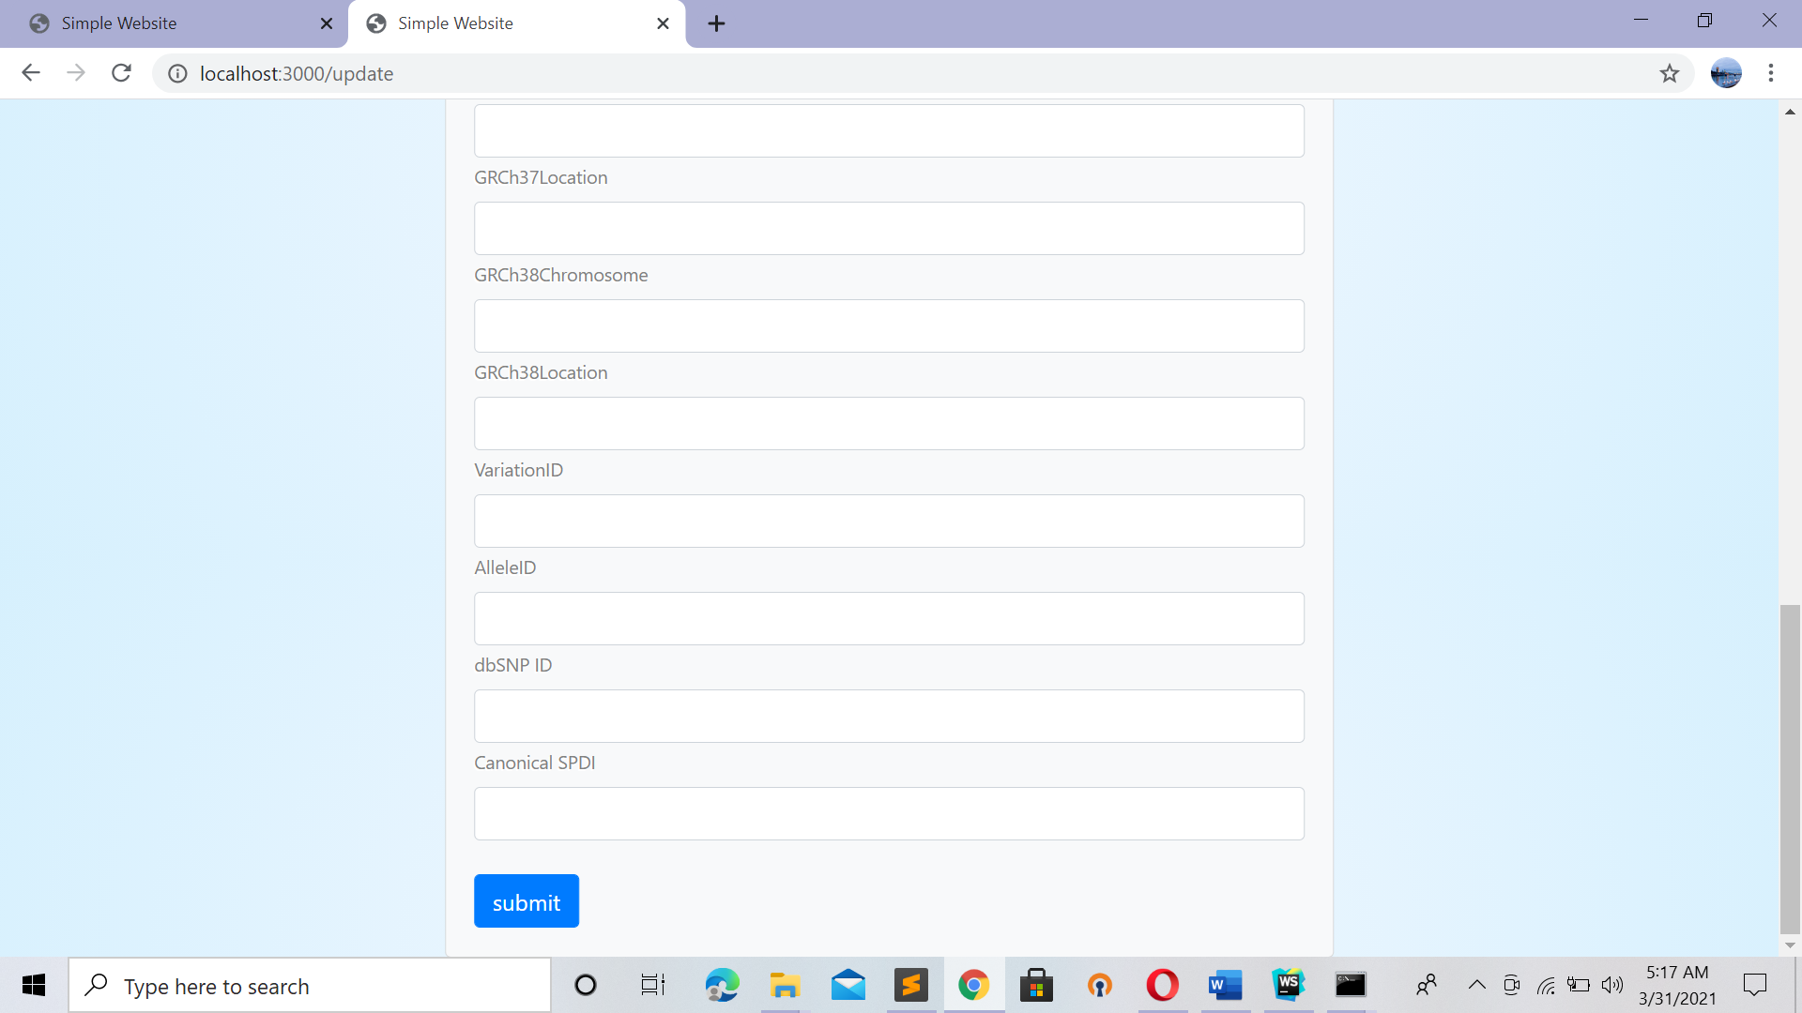

U will get fetch Time . Bur Not every time U get Same Val . lets Judge By experiment

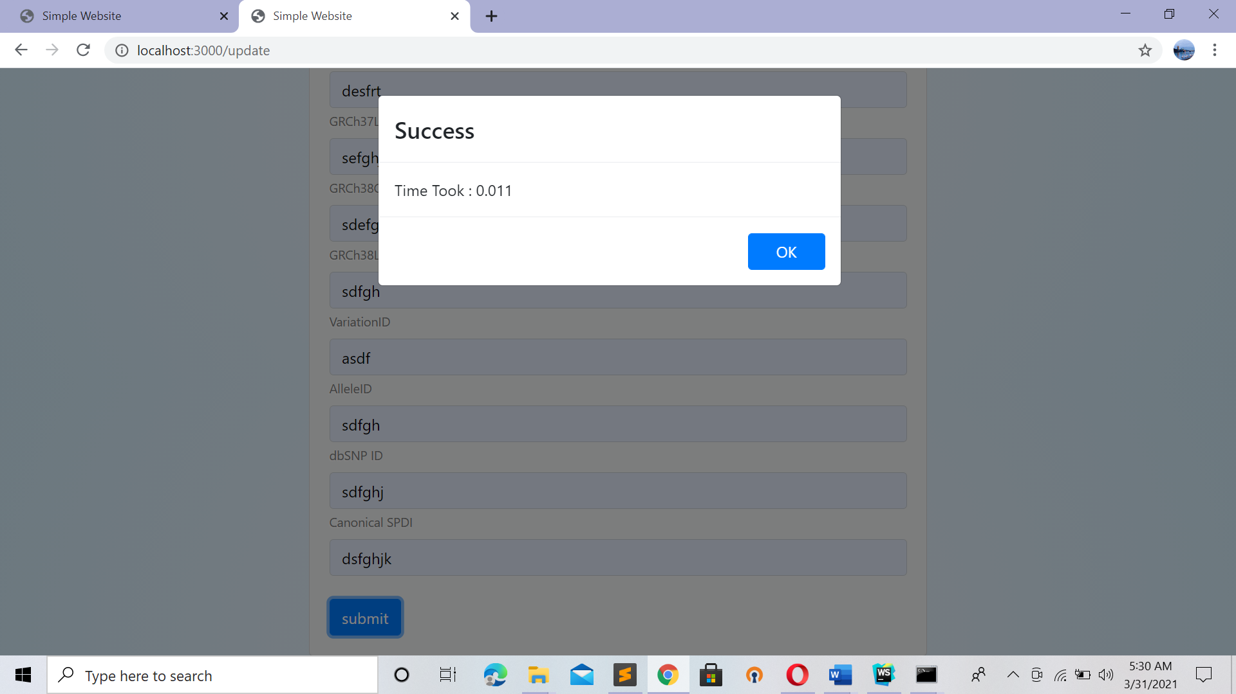

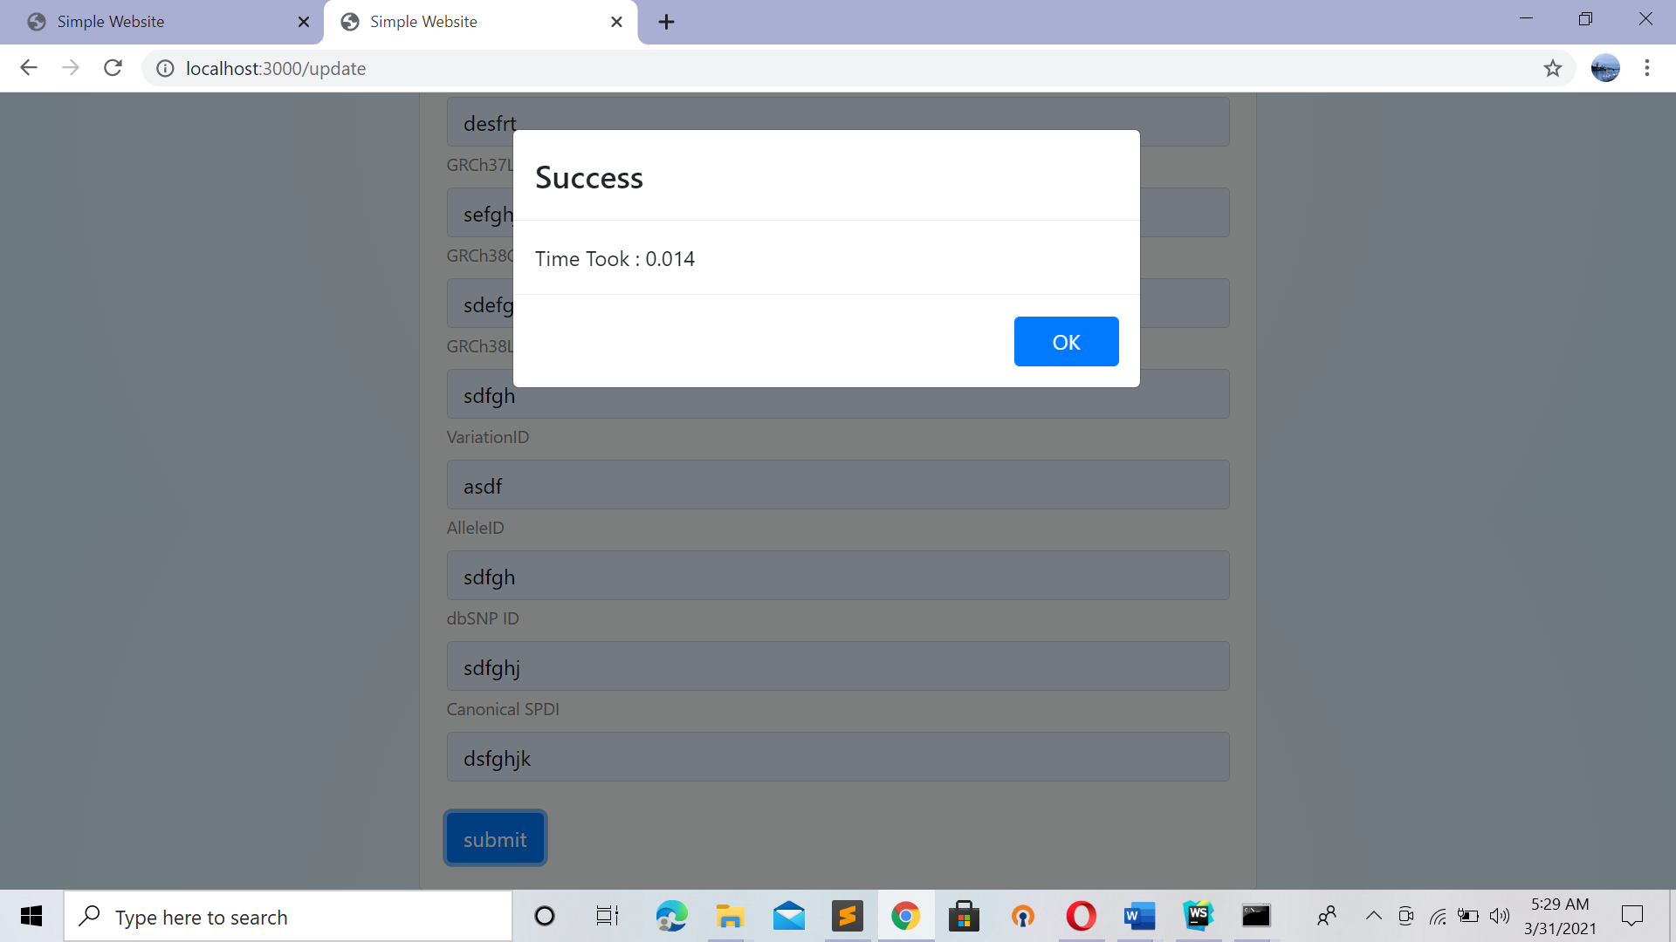

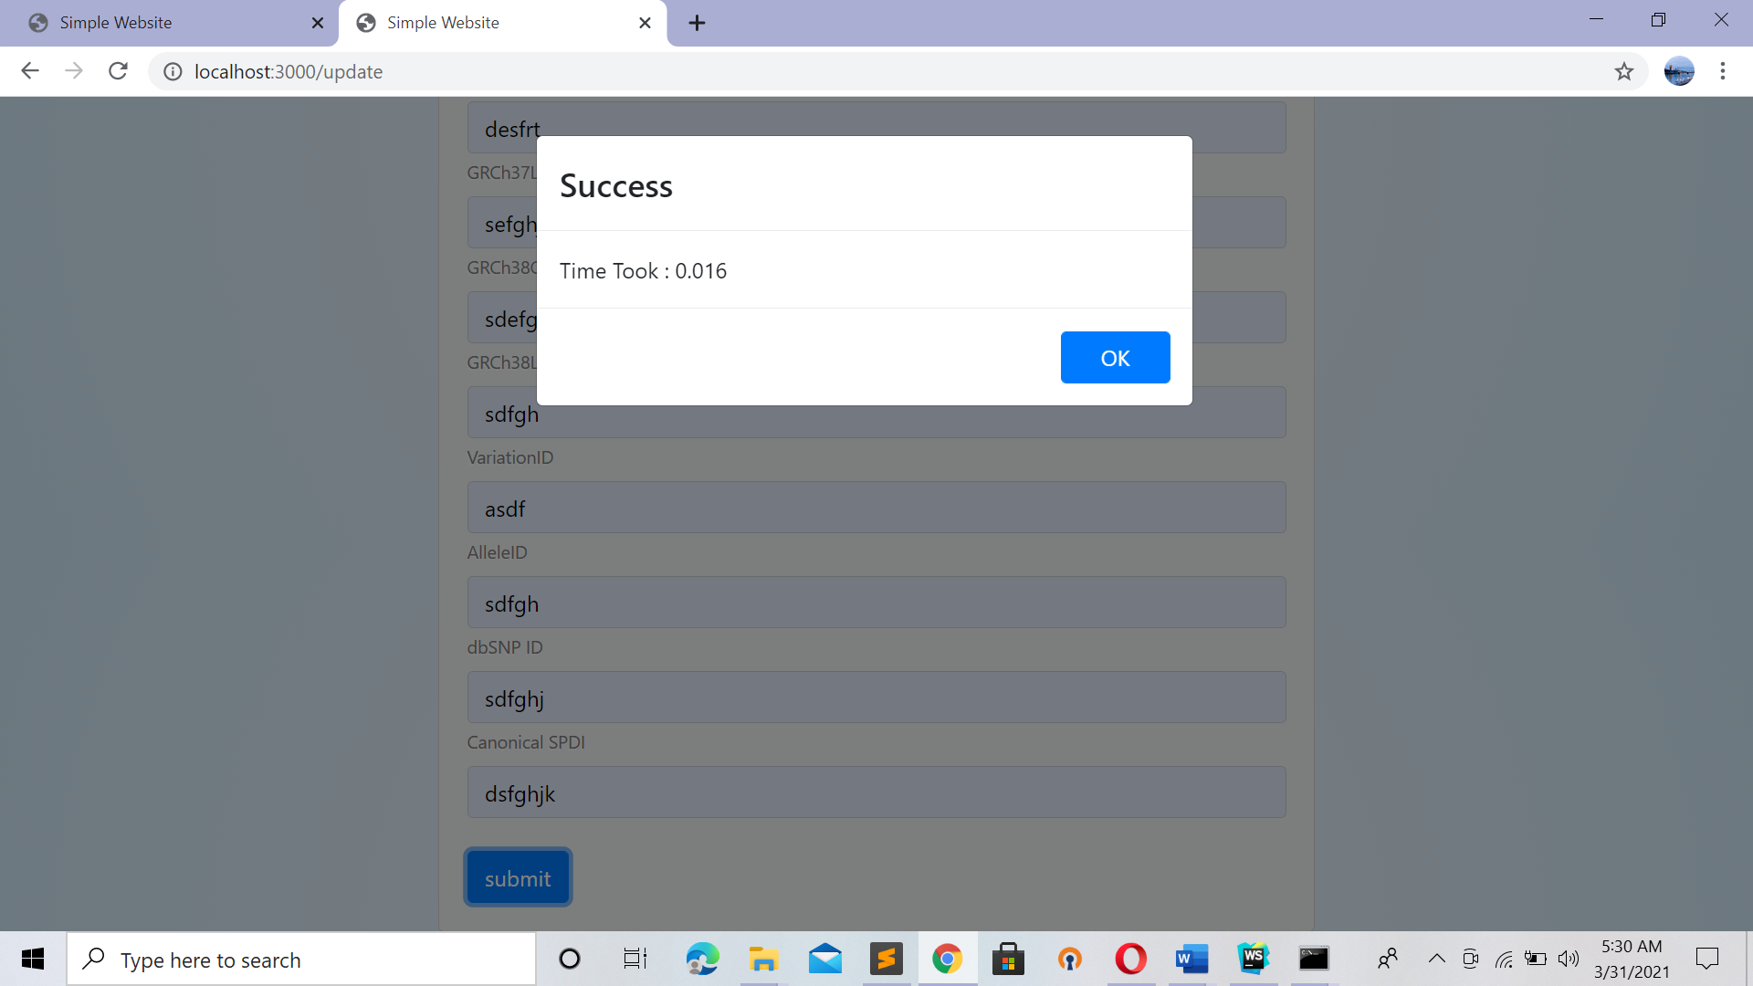

Account -> click

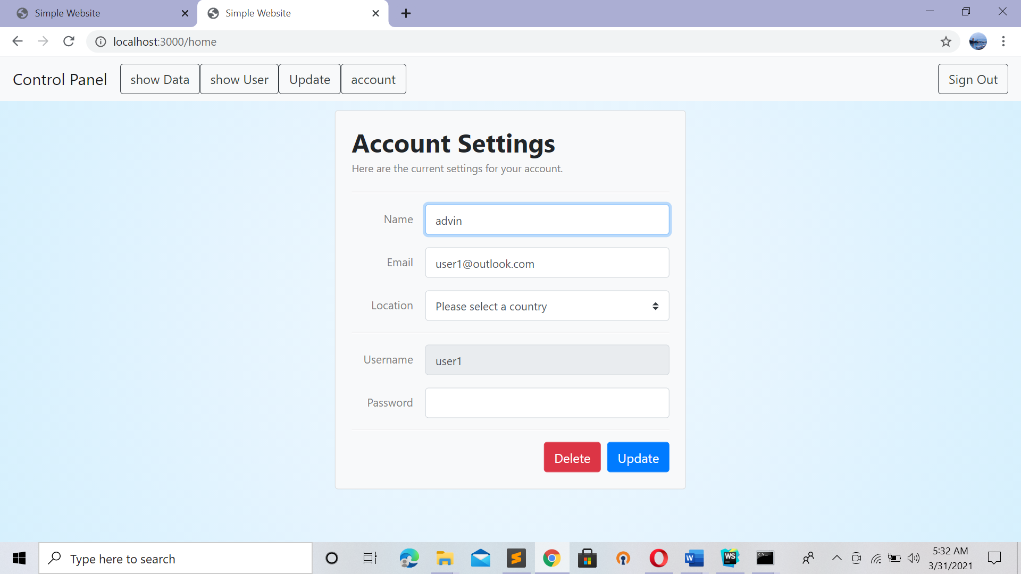

This portal is usefull for Update Personal Data Like

Username

Country

Passwd

Etc

Another option is delete account

Once U delete U wont be accessed to Ur Account Untill U make one

**So At the end It doesn’t require any separate server to run It will included in Node js**